**University Catalog Management System Version 2.0**

Mentor:

Tim Downey

Team Members:

Jose Astudillo

Christopher Sutton

Senior Project

CIS 4911 – U01

Masoud Sadjadi

September 4th, 2014

Copyright © by Florida International University – Senior Project – UCMS Team

All rights reserved. No part of the University Catalog Management System Project or its documentation may be reproduced or transmitted in any form or by any means without prior written consent of the UCMS Team.

*This page was intentionally left blank*

# Executive Summary

For the fall 2014 semester we undertook the project of making modifications to the University Catalog Management System (UCMS) which is an online repository and encyclopedia for past, present, and future university catalogs here at FIU. In this document we will begin with an introduction of the project and what we are trying to achieve through our feasibility study of the desired components. Throughout the feasibility study we look at certain functionality and analyze their value to the system and their level of difficulty which ultimately helps gauge whether or not a particular function would fit in this current development cycle.

In addition to the feature we implemented this document will also look at our project plan which assisted in keeping the project on track throughout the semester. Requirements for the new features are also described in addition to a detailed description of the system design. Information such as the use cases that were implemented and system diagrams will also be provided to assist the understanding of how the system was developed.

In addition to our planning and development phase a section with regards to system validation has also been added in order to emphasize how the system has been tested. As this is a working system it is critical that no redundant or incorrect data is submitted to the database through any changes we make as this would counter the usefulness of the UCMS system

The appendix contains miscellaneous information such as use cases, diagrams, and models for the system. In addition a diary has been included that details every meeting with our client, Tim Downey, throughout the semester.

Table of Contents

Executive Summary 2

Introduction 5

Problem Definition 5

Scope of the System 5

Definitions, acronyms, and abbreviation 6

Definitions: 6

Acronyms: 7

Overview of Document 7

Feasibility Study 8

Description of Current System 8

Description of Alternative Solution 8

Recommendations for Solution 9

Project Plan 1

Project Organization 1

Project Personnel 1

Hardware and Software Resources 1

Identification of Tasks, Milestones and Deliverables 2

Cost of the Project 2

System Requirements 3

Functional and Non-Functional Requirements 3

Requirements Analysis 7

System Design 9

Overview 9

Subsystem Decomposition 9

Hardware and Software Mapping 10

Persistent Data Management 11

Security/Privacy 14

Detail Design 16

Overview 16

Static Model 16

Dynamic Model 19

Code Specifications 36

System Validation 41

Subsystem Tests 41

System Tests 41

Evaluation of Tests 41

Glossary 42

Appendix 43

Appendix A - Project schedule (Gantt chart or PERT chart). 43

Appendix B – All use cases with nonfunctional requirements. 44

Appendix C – User Interface designs. 65

Appendix D – Analysis models 72

Appendix E – Design models (static and dynamic) 72

Dynamic Model 75

Appendix F – Documented Class interfaces (code) and constraints. 92

Appendix G – Documented code for test drivers and stubs. 97

Appendix H – Diary of meetings 97

References 108

# Introduction

The School of Computing and Information Sciences, SCIS, offers a variety of degree programs with multiple tracks designed to help students reach their educational goals. Every department at Florida International University offers the same structure of degree programs. Currently advisers have to refer to a catalog for each degree path to properly advise students correctly. The University Catalog System will act as an online resource for advisers when they are assisting students.

The University Catalog Management System is a system designed to easily create and manage curriculum information through a centralized user friendly web application. By centralizing this resource online for the SCIS department, the university will be able to scale this system across multiple degree granting units which could will benefit many users at FIU.

## Problem Definition

The University Catalog System is currently in a working state however there exists several possible enhancements that can be made in order to greatly increase the productivity of students and advisers who would use the system. Additional features such as flowchart visualization, enhanced user functionality, user interface enhancements, the ability to propose catalogs, and solid documentation are considered the top priorities associated with this project.

Currently catalogs are recorded through physical catalogs distributed to advisers and made available to students online as a PDF. However this is not a very dynamic approach to documenting data such as degree paths. By moving the catalogs online users will have increased search capabilities in finding information relevant to their majors. In addition to creating a good user experience for students, we also plan to focus on the advisers and how this system can benefit their everyday needs. Advisers sometimes need to quickly be able to switch between catalogs and search for various degrees and degree tracks. By creating an automatic algorithm for the creation of flowcharts, advisers will no longer have to rely on Microsoft Visio to design a degree path, instead they could directly manipulate courses via the flowchart visualization. Having a single platform that could archive previous and display current catalogs will provide a dynamic experience for all users.

## Scope of the System

During the fall semester we plan to enhance the University Catalog System which is an application intended for students and advisers which would allow them to quickly view degree paths and a description about each course. The catalog system acts as a virtual encyclopedia for degrees at FIU enabling users to view previous year’s catalogs.

Currently the catalog system is displayed in the following format:

Within each degree program, information with regards to the number of credit hours, and a brief description is included. Each course is a part of some set within some degree track, and each course has a variety of information associated with it. Each course has a course name, a course identification which usually consists of a department acronym and a course number, number of credits, and a pre/co-requisites list.

## Definitions, acronyms, and abbreviation

### Definitions:

|  |  |
| --- | --- |
| **Administrator** | Registered user with credentials. User has elevated privileges and can give access to other users. |
| **Adviser** | Registered user with credentials. Adviser acts as a point of contact for students when they have questions with regards to their courses. |
| **Catalog** | Catalog is a publication issued by the university each year that documents all degrees offered and their courses required for graduation. |
| **Degree** | Associates, bachelors, masters, or doctorate level of education. We are focusing on undergraduate. |
| **Degree Granting Department** | A general governing body at FIU that is authorized to offer classes that teach the topics required for graduation with an undergraduate degree. |
| **Electives** | Courses that are not required by the degree program but allow students to explore additional interests within their major. |
| **Lead Adviser** | Registered user with credentials. Users will acts as administrators. |
| **Lower Division** | Lower division classes refers to a student’s first 60 credit hours |
| **Major** | A major is a student’s desired focus of study. |
| **Required** | Classes that are required for a specific degree program. |
| **Sciences** | Classes that are a focus on the core science topics such as physics. |
| **Student** | A student at FIU who can access the catalog systems to explore different degree paths. |
| **Upper Division** | Upper division classes refers to classes that are in the core of degree program. Typically they are the last 60 credit hours. |
| **User** | Any general person who uses the system |

### Acronyms:

|  |  |
| --- | --- |
| **Admin** | Administrator |
| **CIS** | Computer and Information Sciences |
| **CSS** | Cascading Style Sheets |
| **DB** | Database |
| **DGU** | Degree Granting Unit |
| **FIU** | Florida International University |
| **GUI** | Graphical User Interface |
| **HTML** | Hypertext Markup Language |
| **JS** | JavaScript |
| **MVC** | Model View Controller |
| **PHP** | PHP: Hypertext Preprocessor |
| **SCIS** | School of Computer Information Sciences |
| **UCMS** | University Catalog Management System |
| **V2.0** | Version 2.0 |
| **Yii** | Yes it is Framework |

## Overview of Document

Throughout this document we will explore the requirements for this projects in addition to the technology we will be using to implement certain features. Over the next chapter we will begin to explore the current system and the current system constraints that we are looking to provide solutions too. Then we will examine the project plan implemented throughout the semester along with our system design and detailed design of new features. Finally we will close with system validation methods used to determine if the system was functioning correctly.

# Feasibility Study

## Description of Current System

The current catalog system has the infrastructure in place to record catalogs and a basic user interface for displaying such information. Three levels of user accounts have been created including students, advisers, admins however not all functionality desired by each user group has been implemented.

The front end is functional and helps provide a clear demonstration of what the system can be used for and how it can benefit advisers. The back end is partially implemented with a majority of the tables and relationships already defined. There are some gaps in the data which will need to be corrected to make this a system that can operate in a real university environment.

Currently there does not exist any functionality to dynamically create flowcharts, instead advisers have to painstakingly create and modify flowcharts using Microsoft Visio.

## Description of Alternative Solution

The database is a constant debate with this catalog system as the longtime goal of this project is for the system to provide versioning control across multiple catalog systems. Right now we are taking an approach to keep in mind this long term of this system by looking to implement historical tables as we add new features to the system. The previous group has already laid the foundation for historical versioning, however it is not fully implemented as of yet.

Florida International University has two variety of flow charts that could be implemented in this catalog system. Below is two examples:

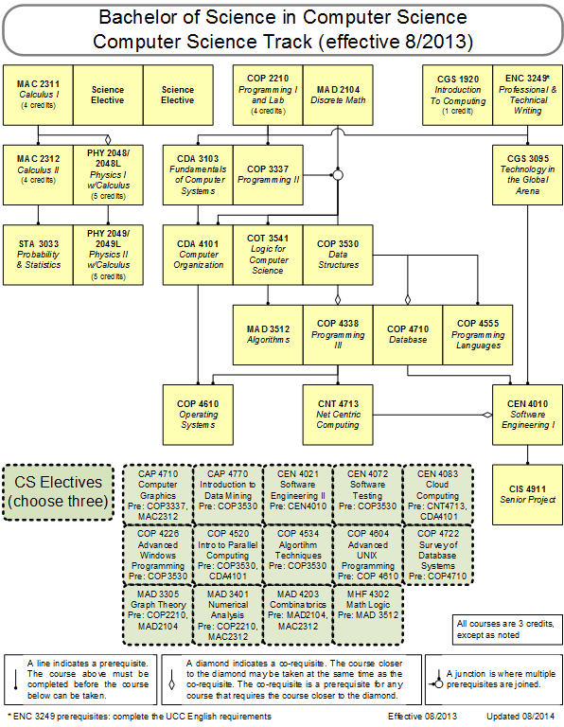 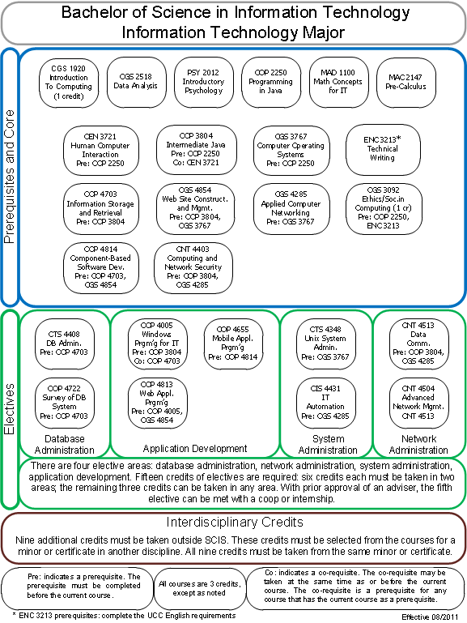

The first flowchart (Add Description) is connected via lines and is often called an organization chart as courses are organized by their pre requisites. The second flowchart (Add Description) is grouped differently and is based on its groups and sets.

If we are unable to implement the organization flow chart the second example of a flow chart can be implemented. The way this flow chart is set up complements the way our database is configured by describing each major through a track, group, set, and then a course list. If we were to implement the second example this can be done using dynamical object modeling using HTML, JS, and CSS. We can also implement functionality that will allow an adviser to dynamically change the structure of a flow chart by allowing them to move individual courses, sets, and groups.

## Recommendations for Solution

Throughout the development of this project we will have to analyze each tradeoff when analyzing solutions to complex problems. Throughout this project we will focus on the following criteria:

* Data Redundancy
* Usability
* Expandability
* Maintainability
* Cost

We will analyze all new features we implement in order to make sure they are feasible based on our selection criteria. By using our criteria as a base line we can ensure that we are creating the best system possible.

Each enhancement we make will need to consume data from our database. In order to ensure our database is efficient we need to minimize the scenario where redundant data is being placed into the database. To combat this the tables already set up provide versioning control and we have to ensure that each database change, whether it be adding additional fields or tables, are able to accommodate multiple versions and promote a one too many structure. In order to create the flow chart dynamically new tables will have to be created in order for a major to have multiple flow charts based on catalog year and track version, this is why creating a one to many reference is critical because a major can have multiple tracks, a track can have multiple groups, a group can have multiple sets, and a set can have multiple courses.

By implementing the second flowchart visualization option based on a group layout usability can be increased by providing the ability to create additional features for the adviser. Considering it would be implemented using dynamic object modelling advisers would be able to manipulate course structures directly via the chart.

The second flow chart option is expandable because it can be used by every degree granting unit at FIU as each degree follows the same structure. The flow chart could act as the foundation for dynamically changing catalog structures.

It is maintainable as the code is generic and relies strictly on accurate data from the database. Each code segment will have a particular function for retrieving courses, formatting them, and laying them out in a particular order as dictated by the flow chart tables.

The cost of creating a dynamic flowchart visualization is high, however this is a feature that our mentor wanted specifically and believe would be a great asset to the system. The second flowchart visualization has a cheaper cost compared to the hierarchal version as the data needed can be modeled directly by creating additional tables and relationships in the database. Its set up is also more concise as we can focus on groups instead of specific requisites for each course.

# Project Plan

In order to ensure a successful project we have created this initial plan with deadlines which we intend to stick by throughout the semester. This will allow us to see whether or not we are on track with our requirements.

## Project Organization

### Project Personnel

This section details the roles of our group members and how we intend to tackle the various aspects of this project.

The team working on this project consists of two members:

* **Jose Astudillo** : Manager, Developer, Tester, System Designer, GUI Designer
* **Christopher Sutton** : Manager, Developer, Tester, Database Manager

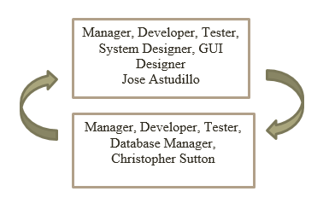

(Add Number) helps us understand better how the team is organized. Each team member will be manager of the other. This means that every work done by a single team member will be revised by its manager. In addition, both members will work on the code, and testing. Each member also has different roles; for example, Jose Astudillo is the System Designer, and Christopher is the Database Manager. However, work will be revised by each other.

### Hardware and Software Resources

The following technologies have been used to build the previous catalog version:

* Yii Framework
* PHP
* HTML/CSS
* MySQL
* Personal Laptops running Windows 7
* MyPhpAdmin Curriculum Database storing SCIS degree information.

While we acknowledge that these are already used throughout the project, we are not limiting our design or implementation to these languages and will be exploring possibilities for adding JS and JQuery.

## Identification of Tasks, Milestones and Deliverables

|  |  |  |
| --- | --- | --- |
|  | Tasks | Task Dependencies |
| **1** | Review Current System |  |
| **2** | Problem Definition | 1 |
| **3** | Obtain High Level User Requirements | 2 |
| **4** | Identify Alternatives Solutions | 3 |
| **5** | Determine Solutions | 4 |
| **6** | Requirement Analysis and Elicitation | 2 |
|  | **Milestone: System Analysis and Implementation** |  |
| **7** | Implement Database Structural Changes | 6 |
| **8** | Populate Database with Data | 6, 7 |
| **9** | Modify System Architecture | 6 |
| **10** | Begin UI Design Modification for Forms | 8, 9 |
| **11** | Begin UI Design for Flowchart | 8, 9 |
| **12** | Implement Functions | 8, 10, 11 |
| **13** | Initial Testing | 8, 12 |
|  | **Milestone: Implemented System Functionality** |  |
| **14** | Finalize System Implementation | 13 |
| **15** | Functional Testing | 13 |
| **16** | Evaluate Test Results | 14, 15 |
| **17** | Complete Final Documentation and Presentation | 16 |
|  | **Milestone: System Complete** | 17 |

## Cost of the Project

The following table shows the cost estimate for developing project.

|  |  |  |
| --- | --- | --- |
| Item | Description | Cost |
| Human Resources | Team member working on the project during the entire development process. | $0.00 |
| Hardware Tools | Laptops | $0.00 |
| FIU Computers | $0.00 |
| Software Tools | Yii Framework | $0.00 |
| Netbeans | $0.00 |
| PHPAdmin | $0.00 |
| Total cost | | $0.00 |

# System Requirements

This chapter defines the functional requirement to be implemented in version 2.0 of the University Catalog Management System project. These requirements are described in terms of functional requirements and their respective nonfunctional requirements.

Our main focus for the duration of this development cycle was working on implementing the flowchart visualization and making changes to the prospective catalog features.

## Functional and Non-Functional Requirements

Below lists the functional requirements in the system. The system shall allow:

**Allow advisors to create prospective catalogs**

* **Usability**: The form to be filled must be easy to follow when filling up.
* **Reliability**: System must work flawlessly 99% of the time.
* **Performance**: Data must be save within 3s seconds.
* **Supportability**: This functionality must work for any browser.

**Allow advisors to propose prospective catalogs**

* **Usability**: The feature must be easy to follow.
* **Reliability**: System must work flawlessly 99% of the time.
* **Performance**: Data must be save within 5s seconds.
* **Supportability**: This functionality must work for any browser.

**Allow admin to accept prospective catalogs**

* **Usability**: The feature must be easy to follow.
* **Reliability**: System must work flawlessly 99% of the time.
* **Performance**: Data must be save within 5s seconds.
* **Supportability**: This functionality must work for any browser.

**Allow admin to reject prospective catalogs**

* **Usability**: The feature must be easy to follow.
* **Reliability**: System must work flawlessly 99% of the time.
* **Performance**: Data must be save within 5s seconds.
* **Supportability**: This functionality must work for any browser.

**Allow admin to view prospective catalogs**

* **Usability**: The feature must be easy to follow.
* **Reliability**: System must work flawlessly 99% of the time.
* **Performance**: Catalog must be displayed save within 5s seconds.
* **Supportability**: This functionality must work for any browser.

**Allow admin and students to view track flowchart**

* **Usability**: The feature must be easy to follow.
* **Reliability**: System must work flawlessly 99% of the time.
* **Performance**: Flowchart must be displayed save within 5s seconds.
* **Supportability**: This functionality must work for any browser.

**Allow admin and students to view group flowchart**

* **Usability**: The feature must be easy to follow.
* **Reliability**: System must work flawlessly 99% of the time.
* **Performance**: Flowchart must be displayed save within 5s seconds.
* **Supportability**: This functionality must work for any browser.

**Allow admin and students to view set flowchart**

* **Usability**: The feature must be easy to follow.
* **Reliability**: System must work flawlessly 99% of the time.
* **Performance**: Flowchart must be displayed save within 5s seconds.
* **Supportability**: This functionality must work for any browser.

**Allow admin to alter flowchart track layout**

* **Usability**: The feature must be easy to follow.
* **Reliability**: System must work flawlessly 99% of the time.
* **Performance**: Flowchart must be displayed save within 5s seconds.
* **Supportability**: This functionality must work for any browser.

**Allow admin to alter flowchart group layout**

* **Usability**: The feature must be easy to follow.
* **Reliability**: System must work flawlessly 99% of the time.
* **Performance**: Flowchart must be displayed save within 5s seconds.
* **Supportability**: This functionality must work for any browser.

**Allow admin to alter flowchart set layout**

* **Usability**: The feature must be easy to follow.
* **Reliability**: System must work flawlessly 99% of the time.
* **Performance**: Flowchart must be displayed save within 5s seconds.
* **Supportability**: This functionality must work for any browser.

**Allow advisor to create prospective course**

* **Usability**: The feature must be easy to follow.
* **Reliability**: System must work flawlessly 99% of the time.
* **Performance**: new prospective course form must be displayed save within 5s seconds.
* **Supportability**: This functionality must work for any browser.

**Allow advisor to create prospective set**

* **Usability**: The feature must be easy to follow.
* **Reliability**: System must work flawlessly 99% of the time.
* **Performance**: new prospective set form must be displayed save within 5s seconds.
* **Supportability**: This functionality must work for any browser.

**Allow advisor to create prospective group**

* **Usability**: The feature must be easy to follow.
* **Reliability**: System must work flawlessly 99% of the time.
* **Performance**: new prospective group form must be displayed save within 5s seconds.
* **Supportability**: This functionality must work for any browser.

**Allow advisor to create prospective minor**

* **Usability**: The feature must be easy to follow.
* **Reliability**: System must work flawlessly 99% of the time.
* **Performance**: new prospective minor form must be displayed save within 5s seconds.
* **Supportability**: This functionality must work for any browser.

**Allow advisor to create prospective track**

* **Usability**: The feature must be easy to follow.
* **Reliability**: System must work flawlessly 99% of the time.
* **Performance**: new prospective track form must be displayed save within 5s seconds.
* **Supportability**: This functionality must work for any browser.

**Allow advisor to create prospective certificate**

* **Usability**: The feature must be easy to follow.
* **Reliability**: System must work flawlessly 99% of the time.
* **Performance**: new prospective certificate form must be displayed save within 5s seconds.
* **Supportability**: This functionality must work for any browser.

**Allow advisor to create prospective major**

* **Usability**: The feature must be easy to follow.
* **Reliability**: System must work flawlessly 99% of the time.
* **Performance**: new prospective major form must be displayed save within 5s seconds.
* **Supportability**: This functionality must work for any browser.

**Allow advisor to edit prospective course**

* **Usability**: The feature must be easy to follow.
* **Reliability**: System must work flawlessly 99% of the time.
* **Performance**: editable prospective course form loaded with current content must be displayed save within 5s seconds.
* **Supportability**: This functionality must work for any browser.

**Allow advisor to edit prospective set**

* **Usability**: The feature must be easy to follow.
* **Reliability**: System must work flawlessly 99% of the time.
* **Performance**: editable prospective set form loaded with current content must be displayed save within 5s seconds.
* **Supportability**: This functionality must work for any browser.

**Allow advisor to edit prospective group**

* **Usability**: The feature must be easy to follow.
* **Reliability**: System must work flawlessly 99% of the time.
* **Performance**: editable prospective group form loaded with current content must be displayed save within 5s seconds.
* **Supportability**: This functionality must work for any browser.

**Allow advisor to edit prospective minor**

* **Usability**: The feature must be easy to follow.
* **Reliability**: System must work flawlessly 99% of the time.
* **Performance**: editable prospective minor form loaded with current content must be displayed save within 5s seconds.
* **Supportability**: This functionality must work for any browser.

**Allow advisor to edit prospective track**

* **Usability**: The feature must be easy to follow.
* **Reliability**: System must work flawlessly 99% of the time.
* **Performance**: editable prospective track form loaded with current content must be displayed save within 5s seconds.
* **Supportability**: This functionality must work for any browser.

**Allow advisor to edit prospective certificate**

* **Usability**: The feature must be easy to follow.
* **Reliability**: System must work flawlessly 99% of the time.
* **Performance**: editable prospective certificate form loaded with current content must be displayed save within 5s seconds.
* **Supportability**: This functionality must work for any browser.

**Allow advisor to edit prospective major**

* **Usability**: The feature must be easy to follow.
* **Reliability**: System must work flawlessly 99% of the time.
* **Performance**: editable prospective major form loaded with current content must be displayed save within 5s seconds.
* **Supportability**: This functionality must work for any browser.

## Requirements Analysis

This section contains the main scenario for the second version of the Catalog Management System:

**Proposing of a Prospective Catalog**

The advisor user has the capability to propose changes in an active catalog as well as to add new information such as majors, minors, certificates, tracks, groups, sets, and courses. To make this possible, it is crucial that the user creates a prospective catalog he/she will work on (UCMSv2 - 0001). After the creation of the catalog the user can access his/her catalog if and only if the catalog has not been proposed yet. The user can make use of the addition of new content (UCMSv2 – 0012 through UCSMv2 – 0018) and edit current information (UCMSv2 – 0019 through UCMSv2 – 0025) which will be information in the prospective catalog the user is creating. Once the user feels that necessary prospective changes to the catalogs have been made he/she can propose it (UCMSv2 – 0002) so that administrators can further review it.

**Accepting and Rejecting Prospective Catalogs**

Once a prospective catalog has been proposed, the administrator has the capability to view the changes (UCMSv2 – 0005). The main purpose of viewing changes is that the administrator can either accept (UCMSv2 – 0004) or reject (UCMSv2 – 0003) the prospective catalog. If catalog has been accepted, the catalogs will become active; otherwise the advisor that proposed the catalog will have to keep working on the mentioned catalog.

**Flowchart Generation and View**

The visualization of a program is an important feature for the CMS. Administrators have the capability to make changes to a track chart. For this to be possible, the user has first of all make changes to the flowchart of a set (UCMSv2 – 0011). After making changes to the set flowchart, user needs to make changes to the group flowchart (UCMSv2 – 0010). Finally, after these changes, user has to make changes to the track flowchart (UCMSv2 – 0009). Once all changes to the flowcharts have been made, all users have the capability to view the program flowchart (UCMSv2 – 0006 through UCMSv2 – UCMSv2 - 0008).

# System Design

This chapter gives a high level description of the system design for the Catalog Management System. It starts by giving and overview of the system by describing the architectures used for this project. Then it explains how the system is decomposed in the different subsystems. Furthermore, it describes how hardware and software are mapped. It also addresses how data is management occurs. Finally, it explains how security and privacy is implemented.

## Overview

The Catalog Management System has been developed based on two architectures. The first one is Model-View-Controller (MVC) which works as the primary architectures. This architecture separates the representation of data (view), the logic of the system (controller), and the data itself (model).

The other is the Data Repository pattern. This pattern is used since all data is stored in a central database created for this project. (LABEL)

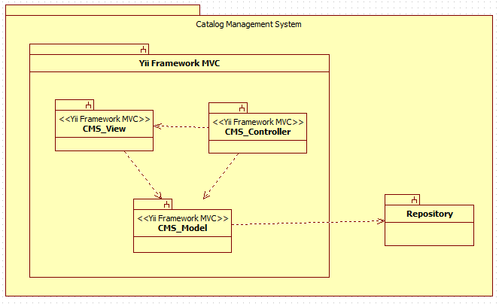

## Subsystem Decomposition

The Catalog Management System consists of four major subsystems, three inside Yii Framework MVC subsystem, and the other is the Repository subsystem.

* **CMS_View:**

This subsystem has all forms that are presented to the user, so that he/she can interact with the system. In addition, this subsystem modifies what is being displayed base on the type of user that is currently interacting with the system. In this subsystem, the user can enter the requests that he/she needs to perform. Once the user has made a request the CMS_View subsystem interacts with the CMS_Controller to process this request.

* **CMS_Controller:**

This subsystem has the logic of the system. Most of the data that is needed to be either displayed or stored goes through here. Furthermore, the CMS_Controller subsystem handles all commands received by the users in order to process their requests. Based on the request this controller will interact with the CMS_Model subsystem to either retrieve or store information in the database.

* **CMS_Model:**

This subsystem provides a way to interact with the data so that can be store or retrieve from the repository. The CMS_Model subsystem receives commands from the CMS_Controller subsystem so that it can get or send information to the repository which contains all data for the system.

* **Repository:**

This is the database where all information of the Catalog Management System is stored. Here is stored data for the users, catalogs, majors, minors, certificates, groups, set, and courses, among others. This subsystem is in direct contact with the CMS_Model subsystem. Once the CMS_Model sends a request the repository performs the action on the data.

Each subsystem is being used in all use cases that have been implemented on the Catalog Management System project.

## Hardware and Software Mapping

The Catalog Management System is hosted on a virtual machine provided by the School of Computing and Information Sciences. This VM runs on Windows 7. Furthermore, it is important to mention that the database “curriculum” is hosted by the SCIS as well. In addition the most current version of the code for the system is stored in the VM so that it can be accessed through the internet. In order to be accessible, the Apache server must be running all the time on the virtual machine. This server connects the code for the system with the database by using XAMPP.

On the other hand, the user can access the system using any PC that has an internet browser. In order to better understanding of the hardware and software mapping for the Catalog Management System, a deployment diagram is provided below. (LABEL)

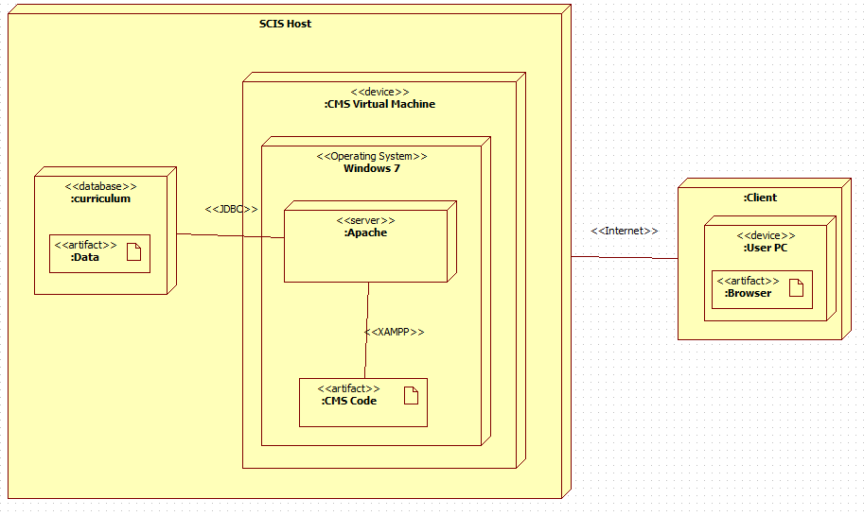

## Persistent Data Management

**User Information Storage:**

The system requires storage of the information of the user that interacts with the system. Among the information about that is stored from the user is the last time he/she logged in into the system, the username, password, time when the user was created, the type of user he/she is, and whether this user is currently active or not.

**Catalog Storage:**

The system requires storage of the different catalog that have been activated in the past, the ones that are proposed, the ones that are prospective, as well as the one that is currently active.

**Current Storage:**

The system requires storage of the current data. This current data refers to the name, catalog id number, as well as the id for the majors, minors, certificates, tracks, groups, sets, and courses that are contained in the different catalogs of the system.

**History Storage:**

The system requires storage of the current data. This history data refers to the description, identifier id number, which is the link to the current data, minimum number of credits, major number of credits, and in some cases notes for the majors, minors, certificates, tracks, groups, sets, and courses that are contained in the different catalogs of the system.

**Relation Storage:**

The system requires storage of the relation that exists between majors and tracks, tracks and groups, minors and groups, certificates and groups, groups and sets, and finally sets and groups. This storage has as main purpose to save the relation between the groups mentioned above.







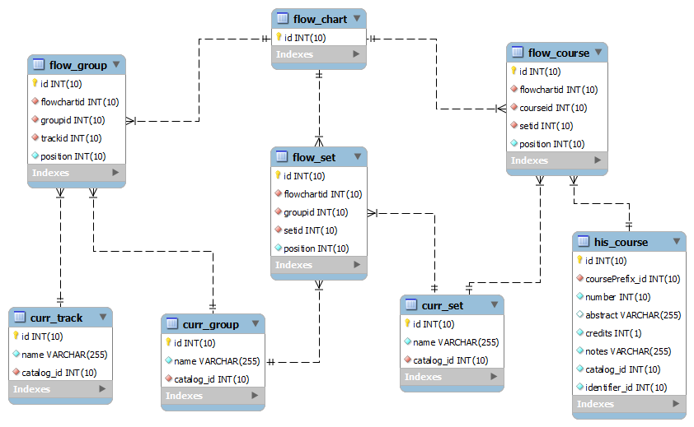

## Security/Privacy

**User authentication process:**

The Catalog Management System has three main users: Administrator, Advisor, and regular visitor or student.

In the case of administrators and advisors, they need to log in with their credentials. On the main webpage of the system, users need to look for the log in button which is located at the end of the action bar (blue colored). Once the log in page is visible, user must provide their credentials, and the click in login, just pressed enter. The system will identify whether the user is administrator or advisor type, and provide them with their respective access to functionalities they can perform.

In the case of regular visitors or student, they are no required to log in to interact with the system. However, they do have access to a minim number of functionalities only.

**Encryption of data:**

Currently, for data encryption, the CMS is using functions provided by Yii - framework. The “encrypting” function take the password the user inputs and converts it to a certain type of string that is composed of different characters, symbols, and digits. At the end the password that is stored in the database is complete changed to what the user entered.

**Use of firewalls and security servers:**

The information held in the “curriculum” database is currently hosted by the School of Computing and Information Sciences (SCIS). This database can only be accessed when connecting directly to the “fiu-cis” network.

The latest version of the system is currently hosted by SCIS as well. This code is in a virtual machine that is directly connected to the “curriculum” database. This connection allows that users accessing to the system through the VM can access data stored in the main database.

# Detail Design

The Detail Design chapter gives a better understanding of the static and dynamic models for the Catalog Management System. Section 3.1 describes the behavior and structure of each subsystem. Section 3.2 shows the different classes along with their methods, and attributes that are part of the system. Furthermore, a minimal class diagrams is provided to help understanding the relationship between classes. Moreover, section 3.3 contains the dynamic model of the system. Here, we can find the sequence diagrams for the use cases that are being implemented for the current version of the project. Main algorithms that have been used are included as well in this section. Finally, section 3.4 describes the class interfaces as well as the constraints for the main control object in each system.

## Overview

The Catalog Management System is basically composed of four subsystems, three of them fall inside the Yii MVC, and the other is the repository. This first subsystem is the controller which is in charge of controlling and processing all command within the system. Without this subsystem, the CMS would be just a bunch of forms and death data. The second subsystem is the view, which allows the user to interact with system. This subsystem makes possible that user can see and enter data to the repository. The third subsystem is the model, which allows the system to interact with the data stored in the database. This means to retrieve or send data to be stored. Finally, the last subsystem is the repository, which has the data for the system.

## Static Model

Here are provided minimal class diagrams for the CMS_Controller subsystem as well as the CMS_Model subsystem. Detailed class diagrams have not been provided in this document due to low visibility of methods, and fields.

CMS_Controller Subsystem:

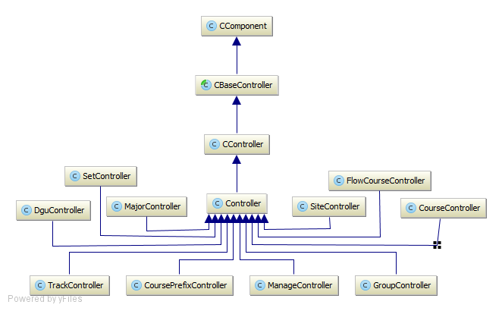

CMS_Model Subsystem:

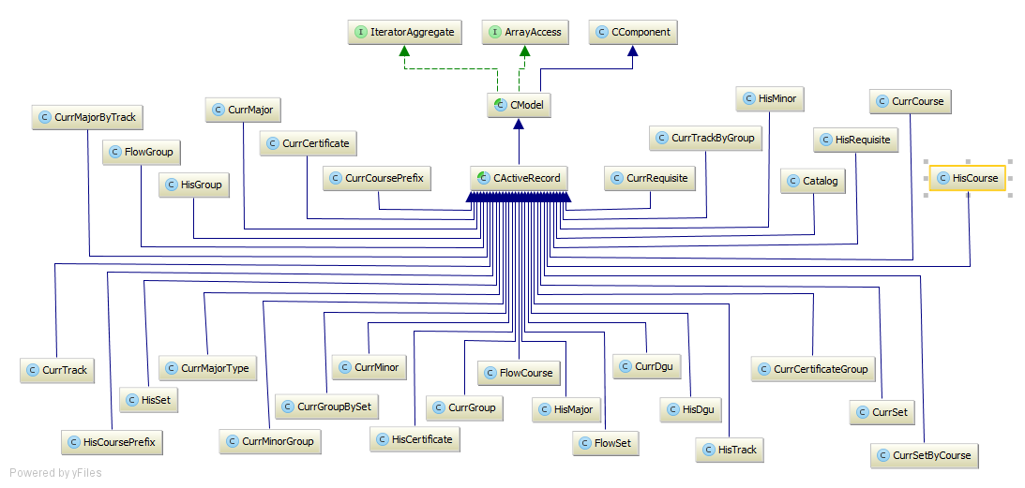

Prospective Catalog Subsystem:

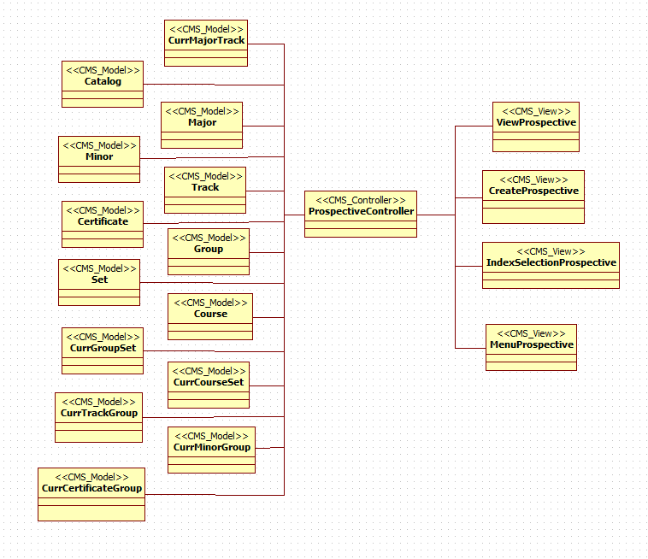

Flowchart Subsystem:

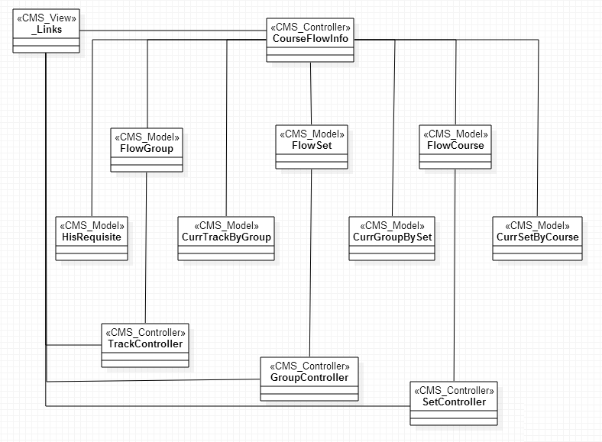

## Dynamic Model

Below are the sequence diagrams refined:

UCMSv2-0001: Create Prospective DGU Catalog:

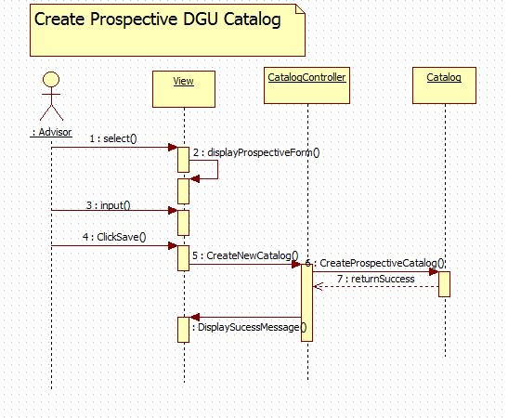

UCMSv2-0002: Propose Prospective DGU Catalog:

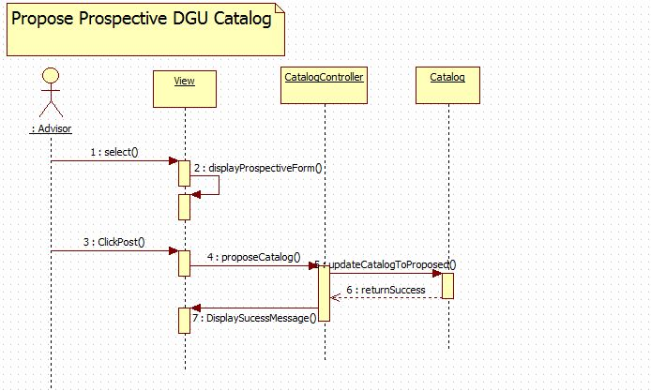

UCMSv2-0003 : Accept Prospective Catalog:

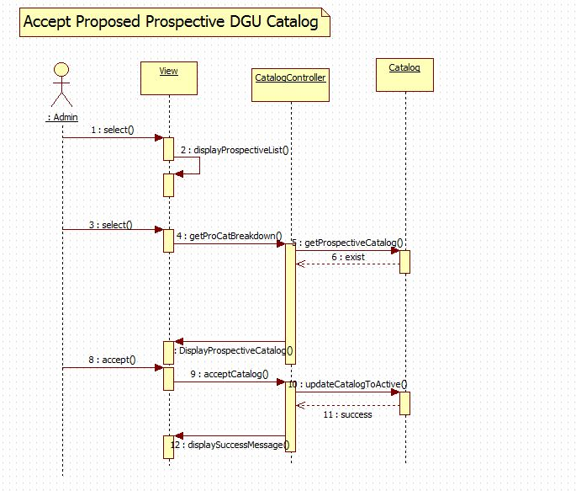

UCMSv2-0004 : Reject Prospective Catalog:

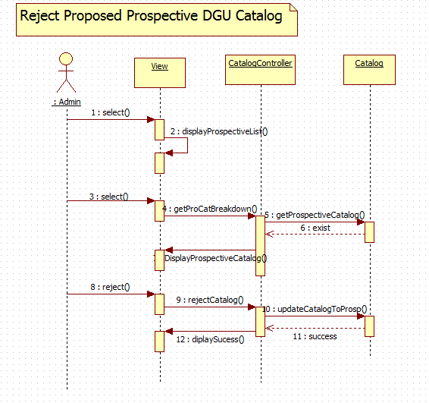

UCMSv2-0005 : View Prospective Catalog:

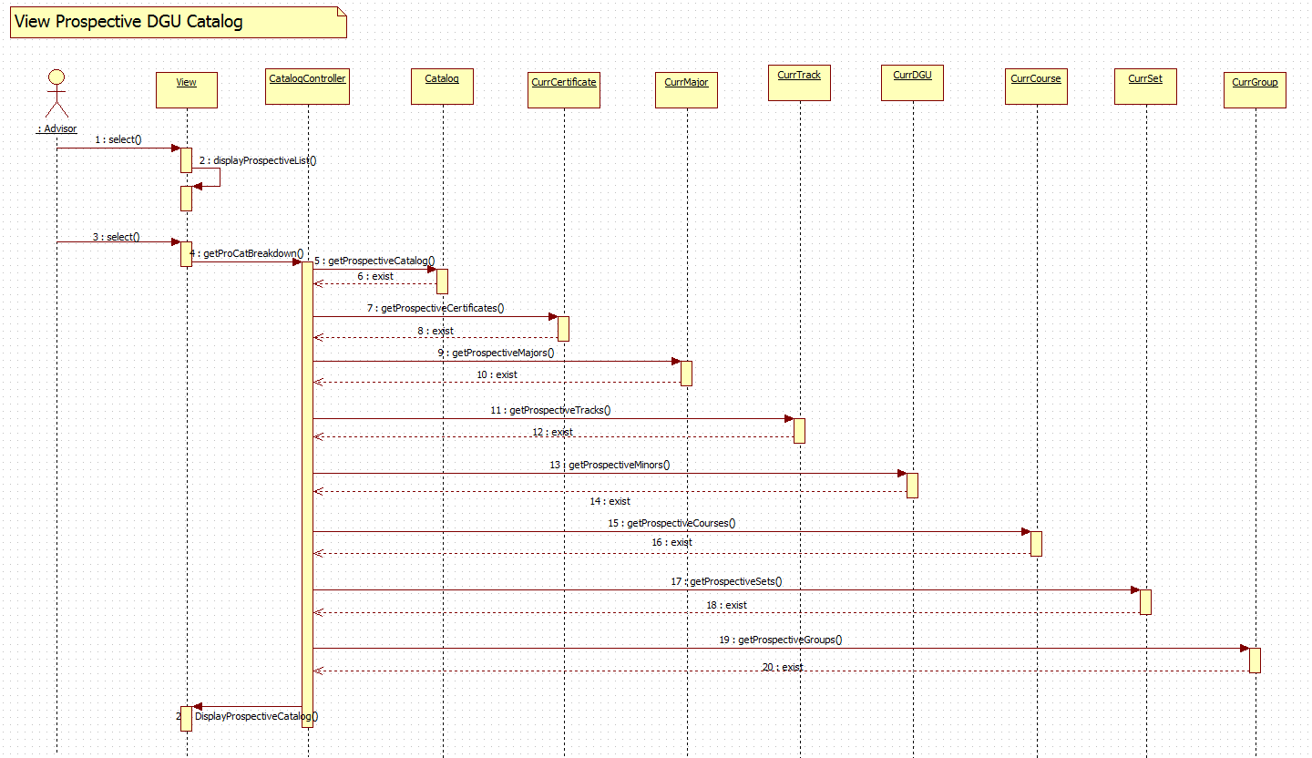

UCMSv2-0006 : View Track Flowchart (a):

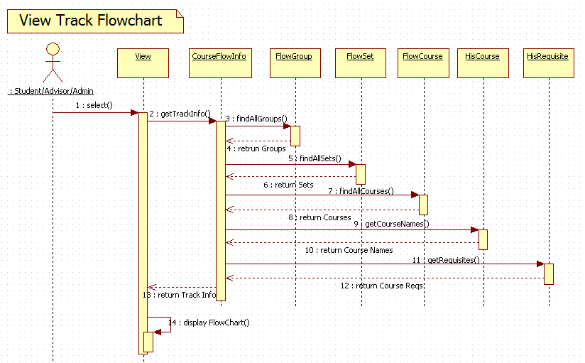

UCMSv2-0006 : View Track Flowchart (b):

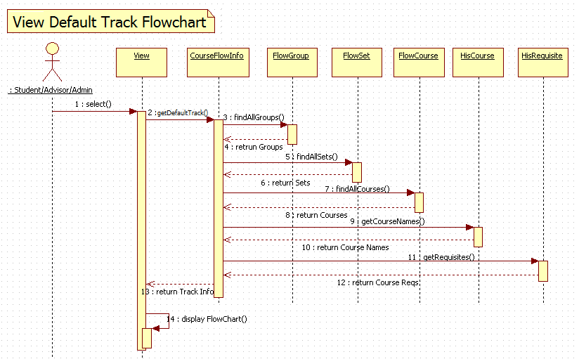

UCMSv2-0007 : View Group Flowchart (a):

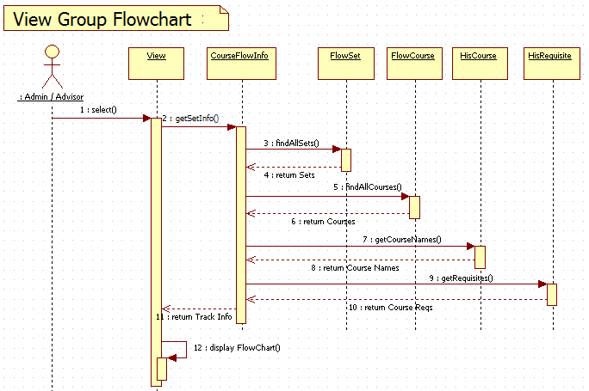

UCMSv2-0007 : View Group Flowchart (b):

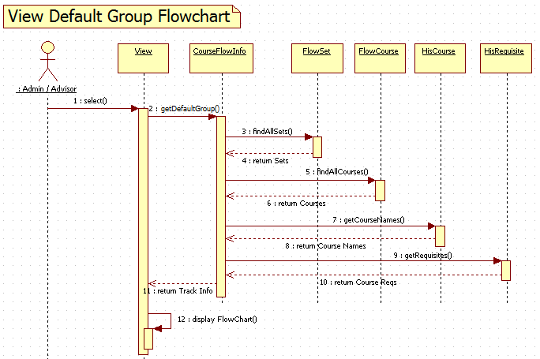

UCMSv2-0008 : View Set Flowchart (a):

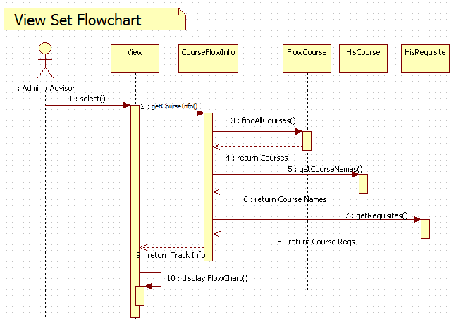

UCMSv2-0008 : View Set Flowchart (b):

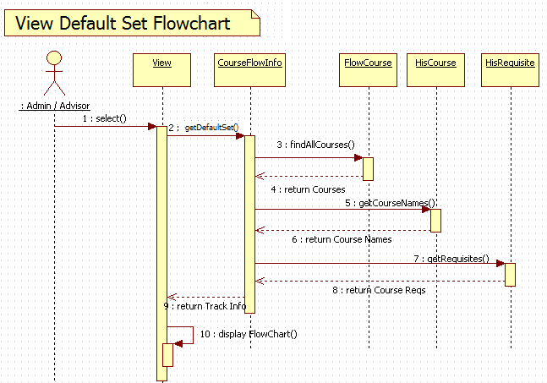

UCMSv2-0009 : Change Track Flowchart:

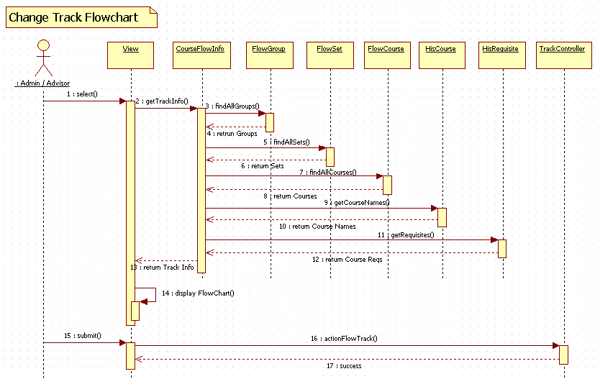

UCMSv2-0010 : Change Group Flowchart:

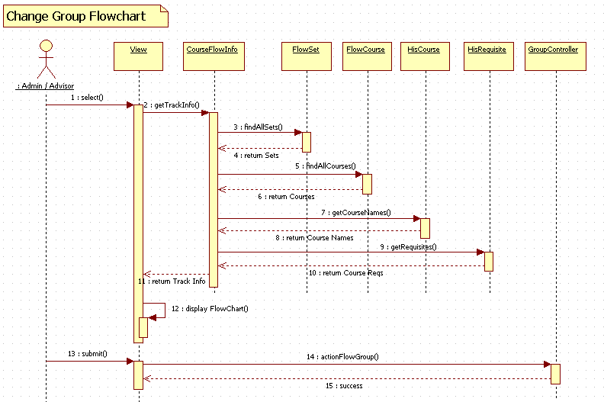

UCMSv2-0011 : Change Set Flowchart:

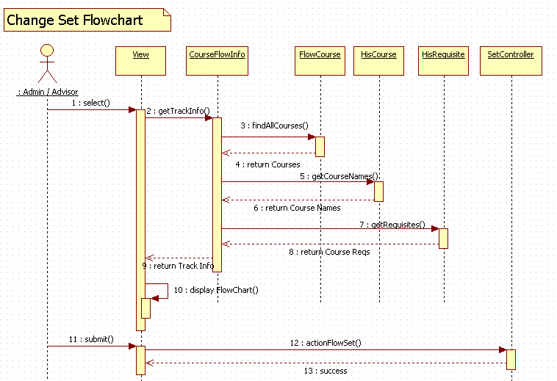

UCMSv2-0012 : Create Prospective Course:

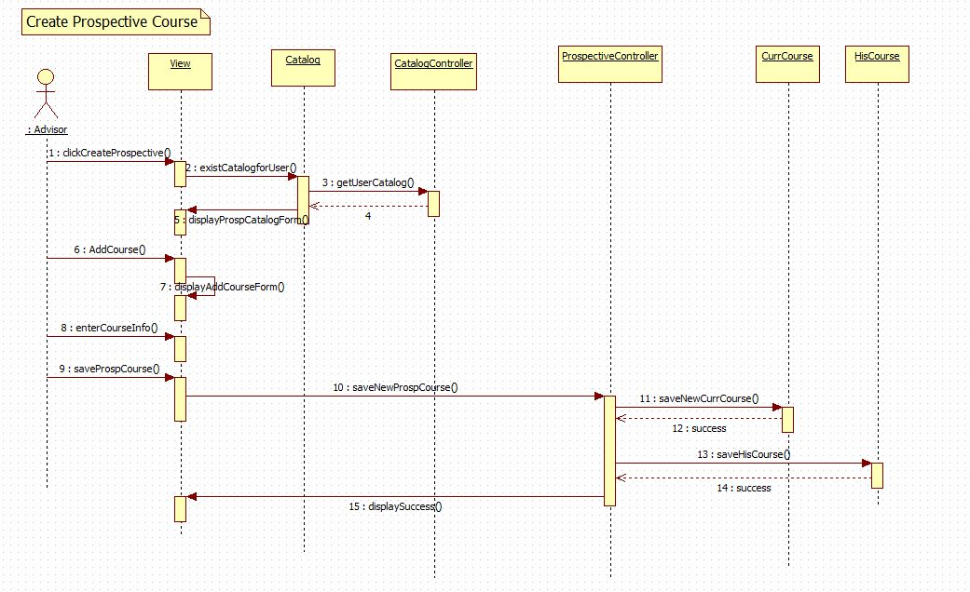

UCMSv2-0013 : Create Prospective Set:

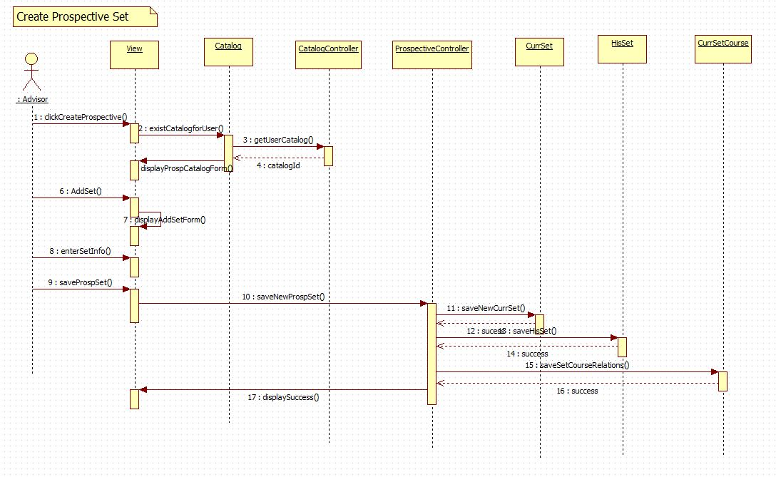

UCMSv2-0014 : Create Prospective Group:

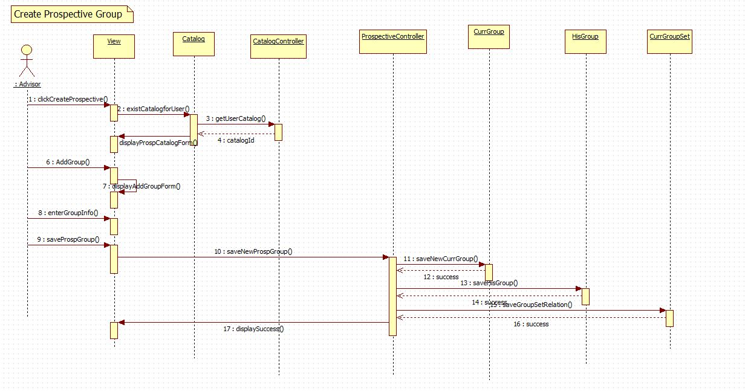

UCMSv2-0015 : Create Prospective Minor:

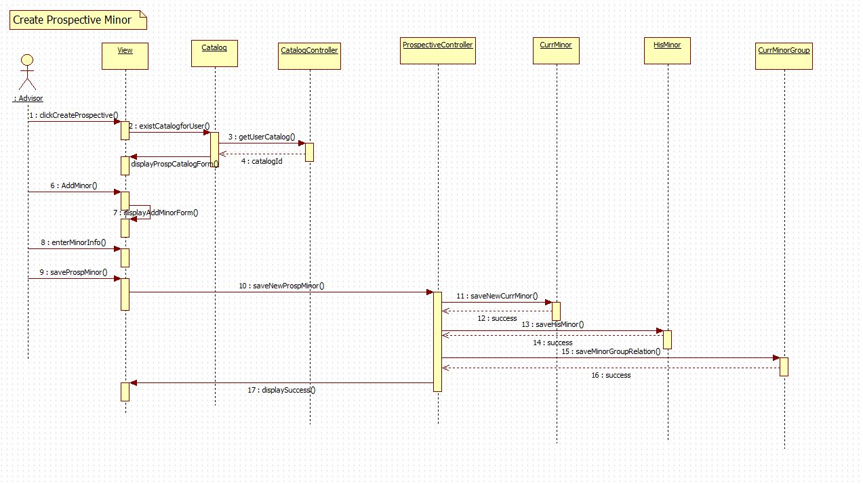

UCMSv2-0016 : Create Prospective Track:

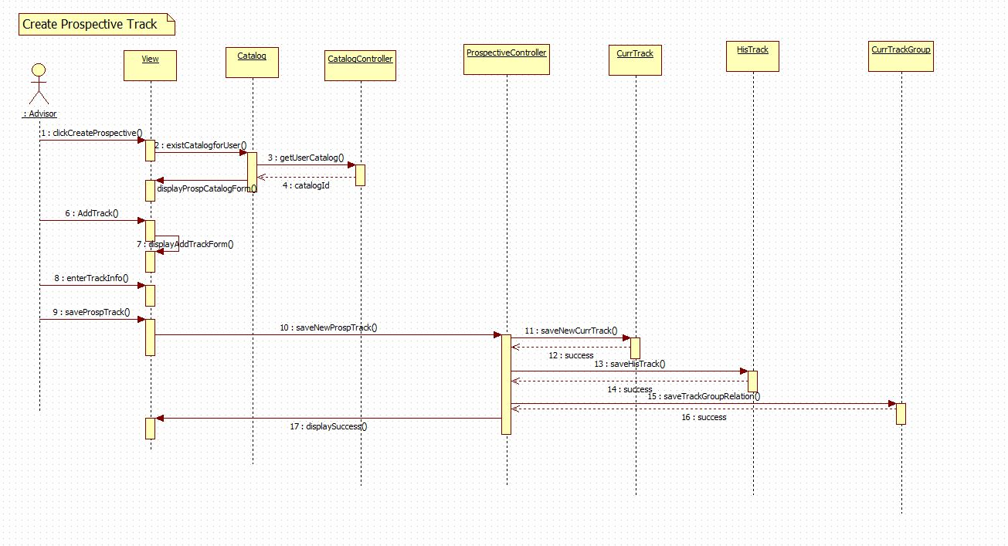

UCMSv2-0017: Create Prospective Certificate:

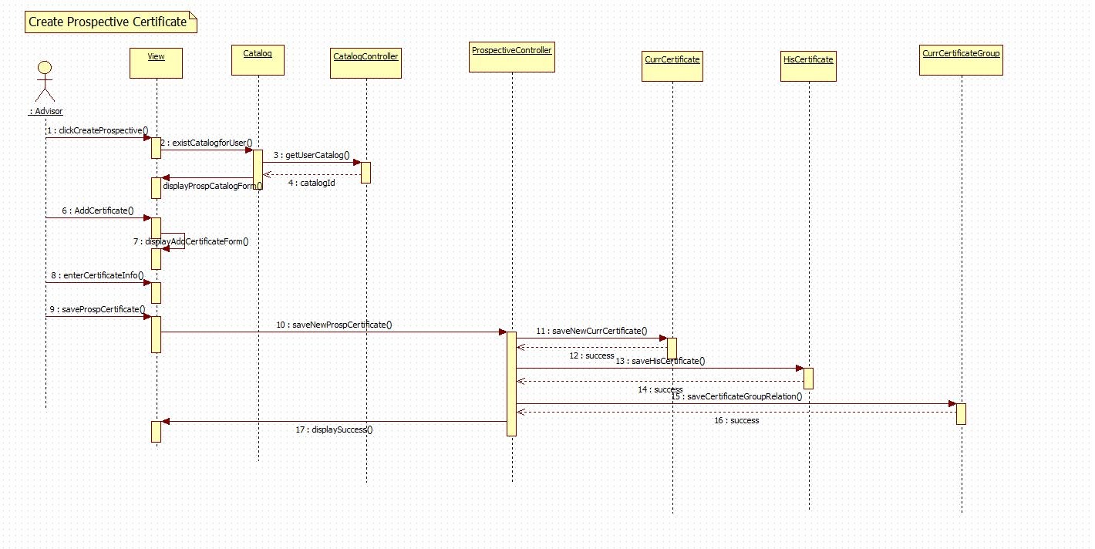

UCMSv2-0018 : Create Prospective Major:

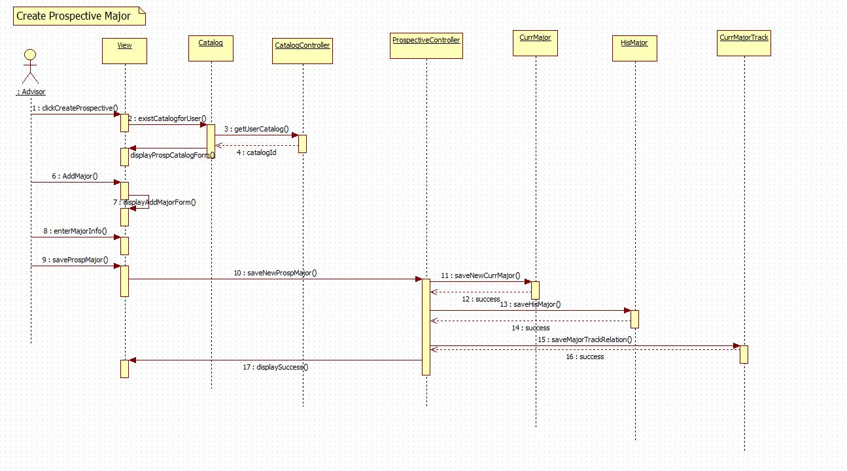

UCMSv2-0019 : Edit Prospective Course:

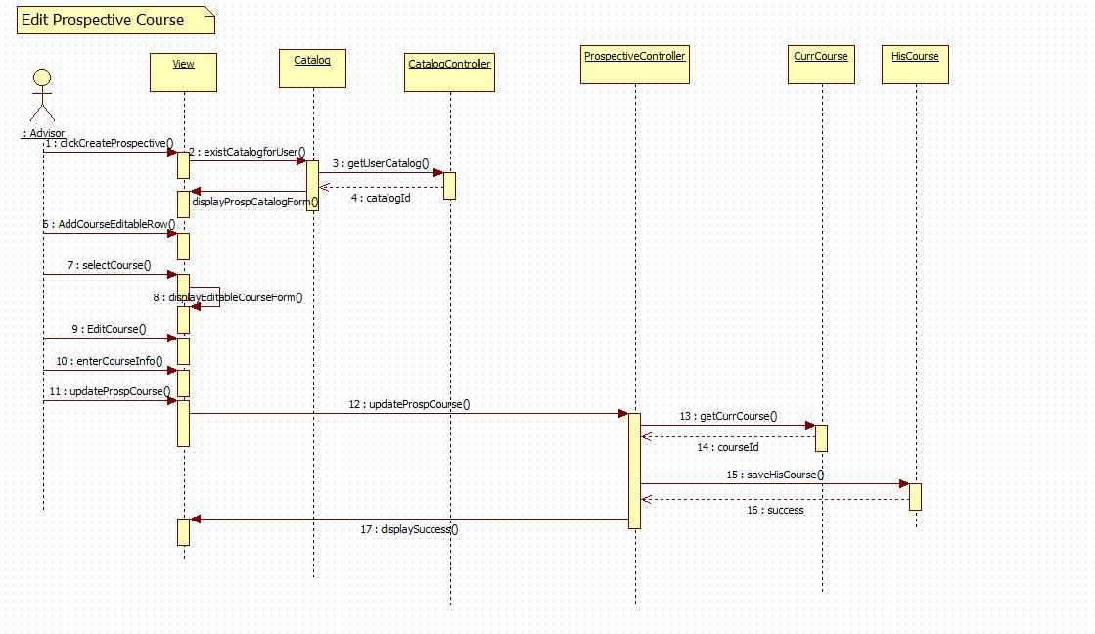

UCMSv2-0020 : Edit Prospective Set:

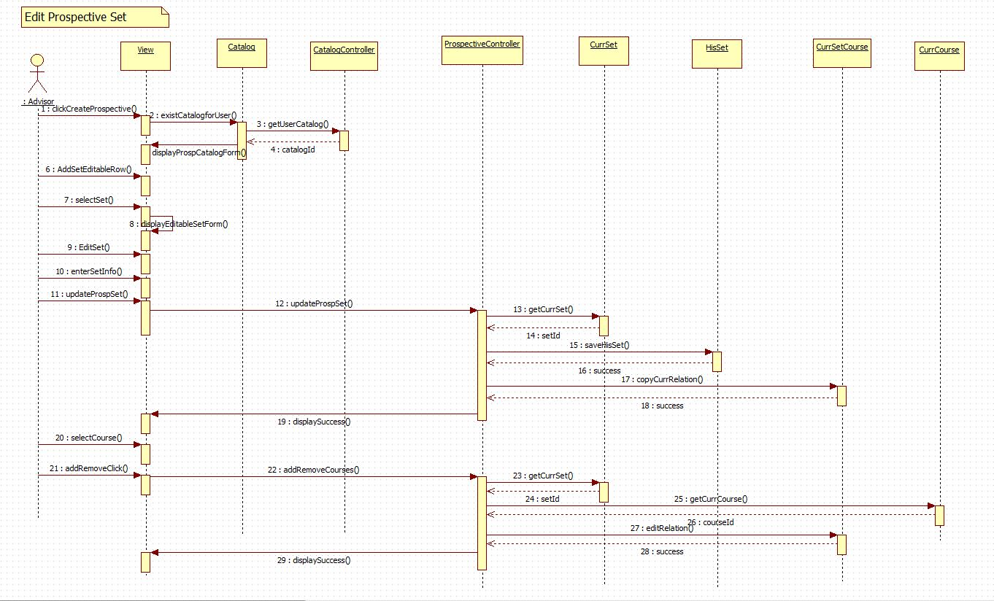

UCMSv2-0021 : Edit Prospective Group:

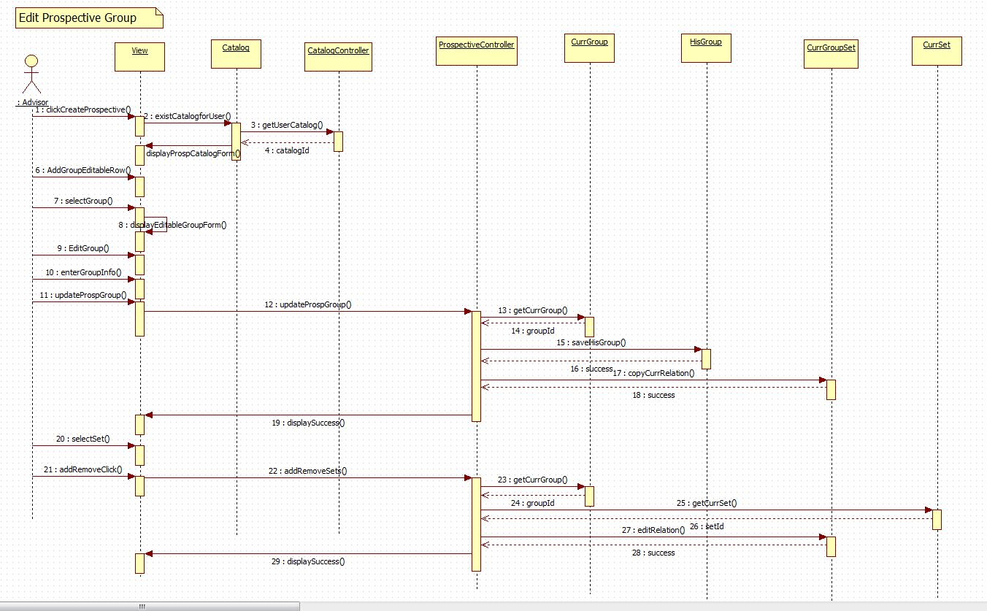

UCMSv2-0022 : Edit Prospective Minor:

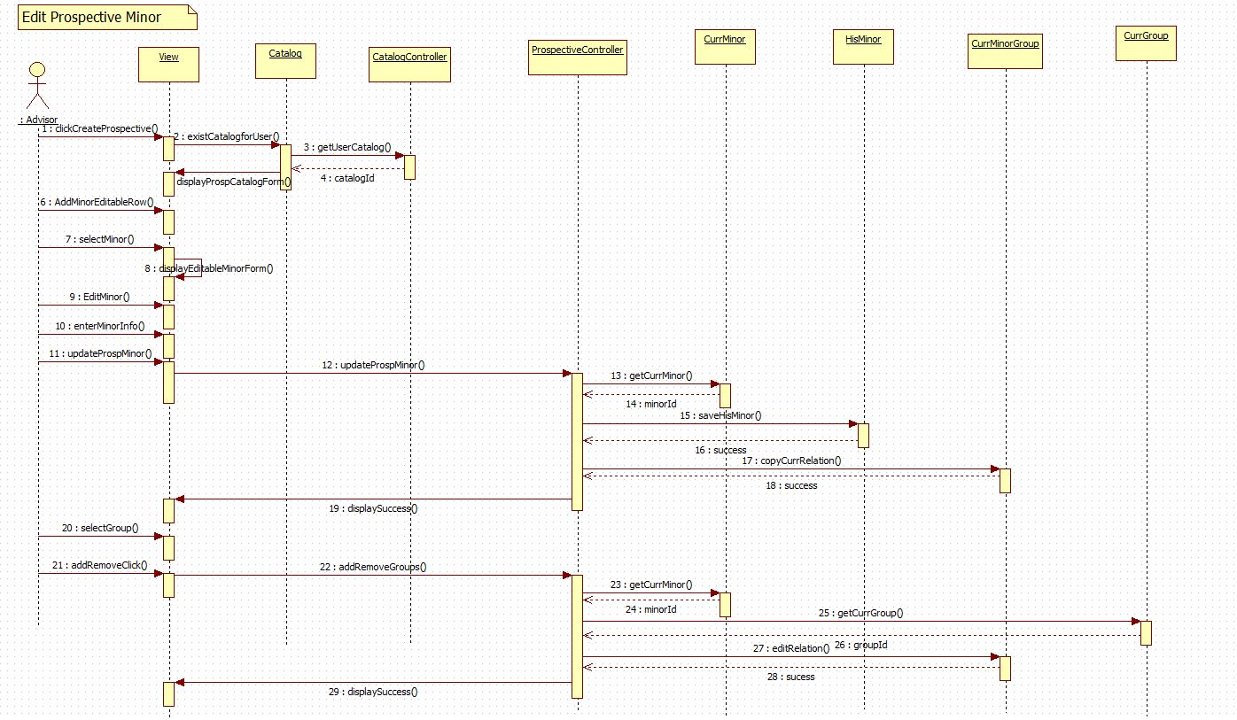

UCMSv2-0023 : Edit Prospective Track:

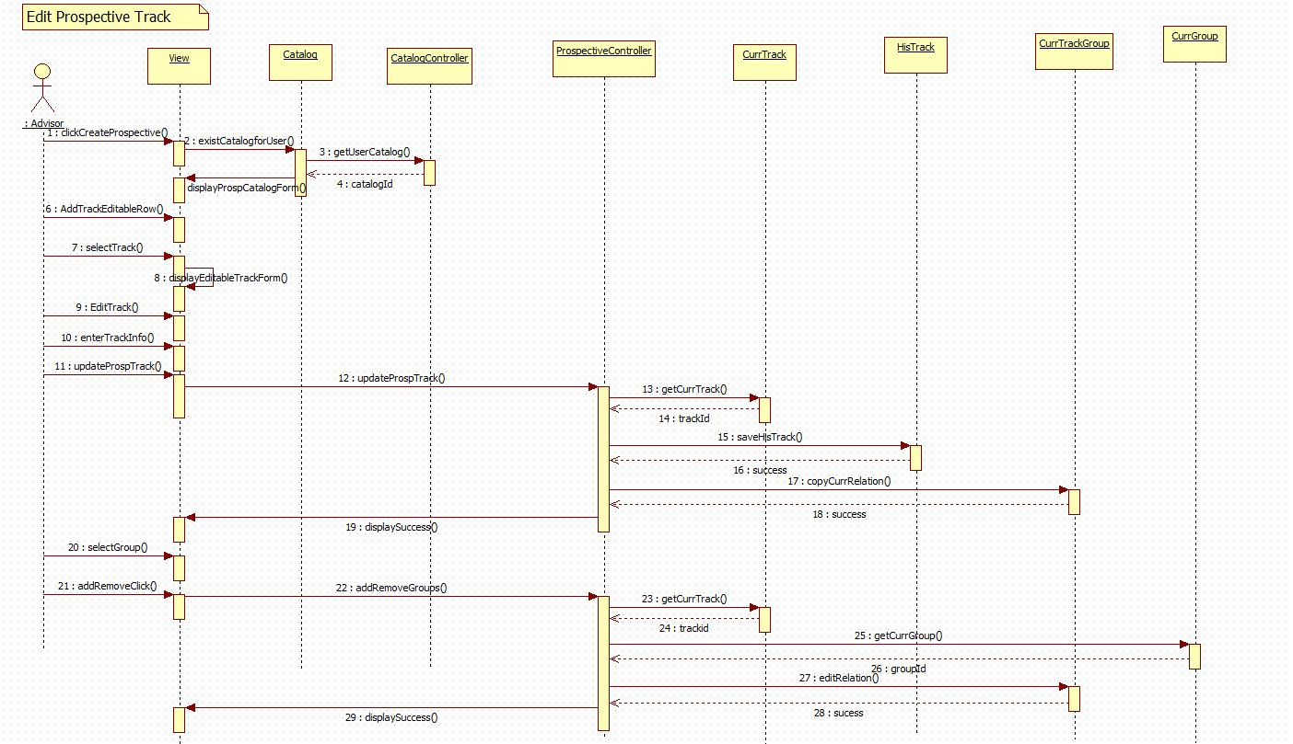

UCMSv2-0024 : Edit Prospective Certificate:

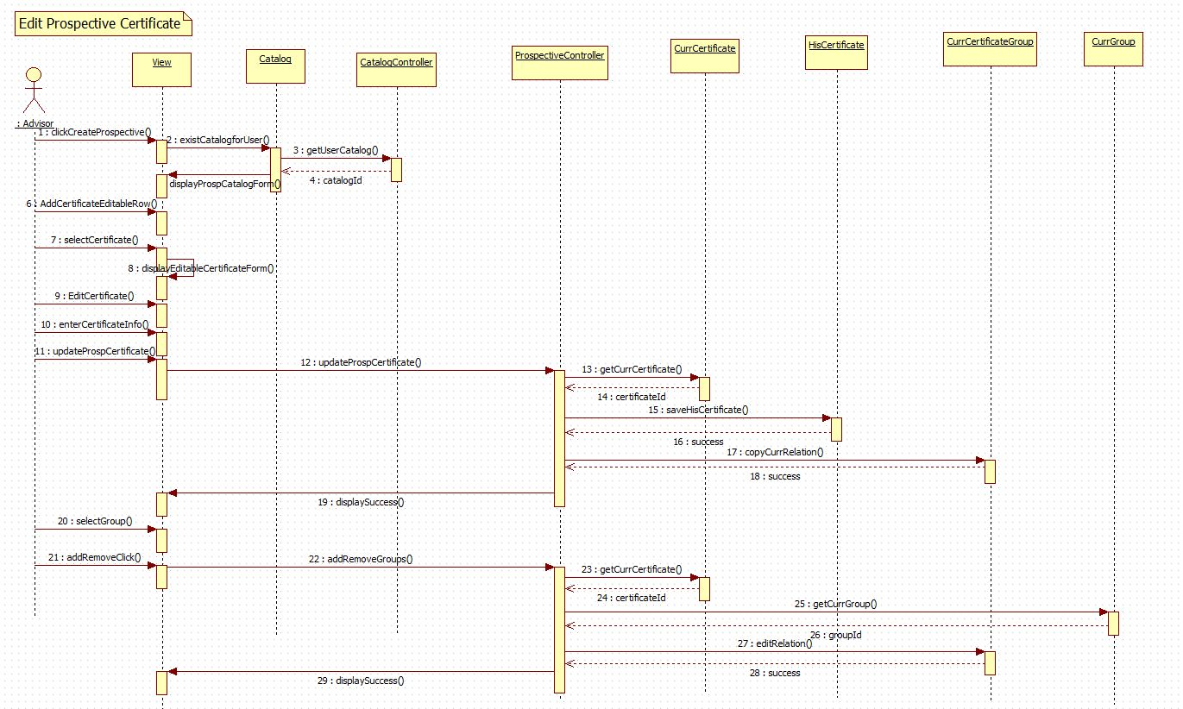

UCMSv2-0025 : Edit Prospective Major:

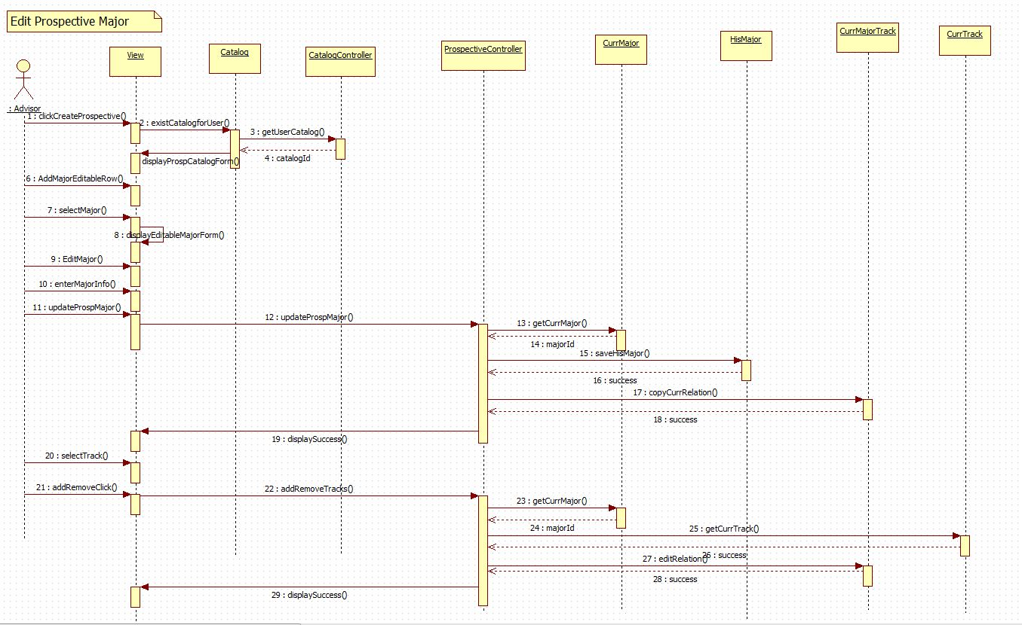

## Code Specifications

In this section, a brief description for some of the methods that are part of the Catalog Management can be found. Additionally, the algorithm for the flowchart view is provided.

**Methods used for the prospective catalog creation:**

These methods can be found in the prospectiveCatalogController.php

* InsertNewCatalog(): this methods insert a new row in the catalog table so that an advisor can make propose changes under this catalog. This method receives information entered for his/her catalog, and then it creates an instance of the catalog model and the saves the data into the catalog table.
* LoadProspectiveCatalogInfo(): this method gets data from the catalog table and displays it for the user that belongs the catalog to.
* ProposeProspectiveCatalog(): this methods sets the isPropose field on the catalog table so that the administrator user can see it in the list to be reviewed.
* AcceptProspectiveCatalog(): this method accepts the catalogs that a user has proposed. This occurs by setting the activated field to 1 and setting to 0 the isProspecive and isProposed field in the catalog table.
* RejectProspectiveCatalog(): this method rejects the catalogs that a user has proposed. This occurs by setting to 1 the isProspecive and to 0 isProposed field in the catalog table for the users catalog.
* SaveNewMajor(): this method receives data that the user entered on the createProspectiveMajorForm. Then creates instances of the CurrMajor, HisMajor, and CurrMajorByTrack modesl. After these instantiations, it checks whether the major already exists, so that it can insert information in all tables. Similar methods are SaveNewMinor(), SaveNewCertificates(), SaveNewTrack(), SaveNewGroup(), and SaveNewSet().These methods interact in same manner with interaction of their current Curr, His, and Relation models.
* UpdateMajor(): this method receives data that user entered in the editProspectiveMajorForm. Then saves the information in the HisMajor table by using the HisMajor models. After this, it copies all existing relation on the CurrMajorByTrack table with the current last active catalog; however, it copies with the catalog id that the user has created. This same mechanism works for UpdateMinor(), UpdateCertificate(), UpdateTrack(), UpdateGroup(), and UpdateSet(). These methods perform same action with the difference that they interact with their respective relation models.
* RetrieveMajorField(): this methods sends back information of major that the user has selected to edit, and therefore propose changes for it. Similar methods are RetrieveMinorFields(),RetrieveTrackFields(),RetrieveCertificateFields(),RetrieveGroupFields(),RetrieveSetFields(), and RetrieveCourseFields().

**Methods used in the flowchart generation:**

The following methods can be found in SetController.php.

* actionFlowSet(): Called after a user has made changes to the format of the Set flowchart model. It first parses the necessary information retrieved via POST in order to make changes to a courses position within the Course display.

The following methods can be found in the GroupController.php.

* actionFlowGroup(): Called after a user has made changes to the format of the Group flowchart model. It first parses the necessary information retrieved via POST in order to make changes to a sets position within the Set display.

The following methods can be found in the TrackController.php.

* actionFlowTrack(): Called after a user has made changes to the format of the Track flowchart model. It first parses the necessary information retrieved via POST in order to make changes to a groups position within the Group display.

The following methods can be found in the CourseFlowInfo.php.

* getCourseInfo(): Accepts an array of courses within a particular set. The function iterates through the array building a string representation of the course. It returns an array containing course information and course ids.
* getSetinfo():When a flowchart does exist for a particular group this function creates a view of the sets using the group id as the input parameter. Returns an array containing course information respective to its saved position, set ids, a set index, and the respective flowchart id. This function relies on finding the position for each element in the flowchart database.
* getTrackInfo():When a flowchart does exist for a particular track this function creates a view of the groups using the track id as the input parameter. Returns an array containing course information respective to its saved position, group ids, a set index and group index, and the respective flowchart id. This function relies on finding the position for each element in the flowchart database.
* getDefaultSet(): When a flowchart does not exist for a particular set this function creates a default view of the courses using the set id as the input parameter. Returns an array containing course information and course ids.
* getDefaultGroup(): When a flowchart does not exist for a particular group this function creates a default view of the sets and courses using the group id as the input parameter. It returns an array of sets that include courses, in addition to set id’s, and the number of sets.
* getDefaultTrack(): When a flowchart does not exist for a particular track this function creates a default view of the groups, sets and courses using the track id as the input parameter. It returns an array of groups that include sets and courses, in addition to groupd id’s, group index and a set index.
* getRequisites(): Accepts an array of courses. Using these courses it iterates through the set and determines what courses have pre-requisites. It then orders the list of courses by the number of pre-requisites the course has in ascending order.

The following methods can be found in the flowchartdrag.js file.

* Box(id, dropState): Initializes three variables based on the parameters passed. Initiaizes the id of the Box as well as the current state, or dropState. The variable value is set to empty.
* allowDrop(obj, ev): Tests to see whether or not the box, or obj, can be dropped in a specific location, ev.
* drag(parent, ev): Acknowledges the box, or parent, is being dragged in a certain environment, ev.
* drop(dropTarget, ev): Ensures that a box can be dropped in a specific location. Inside this function is where the key updates to the metadata is made based on position, flowchart id, and either course, group, or track id.
* dragStart(obj): Changes the boxes border to show that it is being moved to a new location in addition to updating the object source and changing the dragging flag.
* dragEnd(obj): Signifies the end of dragging a specific object by changing the destination border to red and updating field canDrop to true and the isDragging flag to false.

The flowchart visualization can be displayed using two different algorithms:

* 1. If a flowchart for that particular track, group, or set already exists in the database the information will be retrieved from this source.
     1. Track view:
        + 1. Using the track ID and find all groups inside that particular track.
          2. Get each group ID and find all sets inside that group.
          3. Get each set ID inside each group and find the courses inside the sets.
          4. Now place each course information inside an array based on the group’s position, the sets positions, and finally the courses position.
     2. Group view:
        1. Using the group ID find all sets inside that group.
        2. Get each set ID inside each group and find the courses inside the sets.
        3. Now place each course information inside an array based on the sets positions, and finally the courses position.
     3. Set view:
        1. Using the set ID find the courses inside the set.
        2. Now place each course information inside an array based on the courses position.
  2. If a flowchart does not exists we create a standard or default view for the track, group, or set. The information is pulled using the curriculum database.
  3. Track view:
  4. Using the track ID and find all groups inside that particular track.
  5. Get each group ID and find all sets inside that group.
  6. Get each set ID inside each group and find the courses inside the sets.
  7. Apply the requisites algorithm on the set of courses to order the course set in ascending order based on the number of pre-requisites each course has.
     1. Iterate through the list of courses while comparing each course to the number of pre-requisites it has by retrieving information from the his_requisites table.
  8. Now place each course information inside an array based on the group id, set id, and the course order. The group id and set id are placed in ascending order.
  9. Group view:
  10. Using the group ID find all sets inside that group.
  11. Get each set ID inside each group and find the courses inside the sets.
  12. Apply the requisites algorithm on the set of courses to order the course set in ascending order based on the number of pre-requisites each course has.
      1. Iterate through the list of courses while comparing each course to the number of pre-requisites it has by retrieving information from the his_requisites table.
  13. Now place each course information inside an array based on the set id and the course order. The set id are placed in ascending order.
  14. Set view:

1. Using the set ID find the courses inside the sets.
2. Apply the requisites algorithm on the set of courses to order the course set in ascending order based on the number of pre-requisites each course has. Iterate through the list of courses while comparing each course to the number of pre-requisites it has by retrieving information from the his_requisites table.
3. Now place each course information inside an array based on the course order.

# System Validation

## Subsystem Tests

## System Tests

## Evaluation of Tests

# Glossary

# Appendix

## Appendix A - Project schedule (Gantt chart or PERT chart).

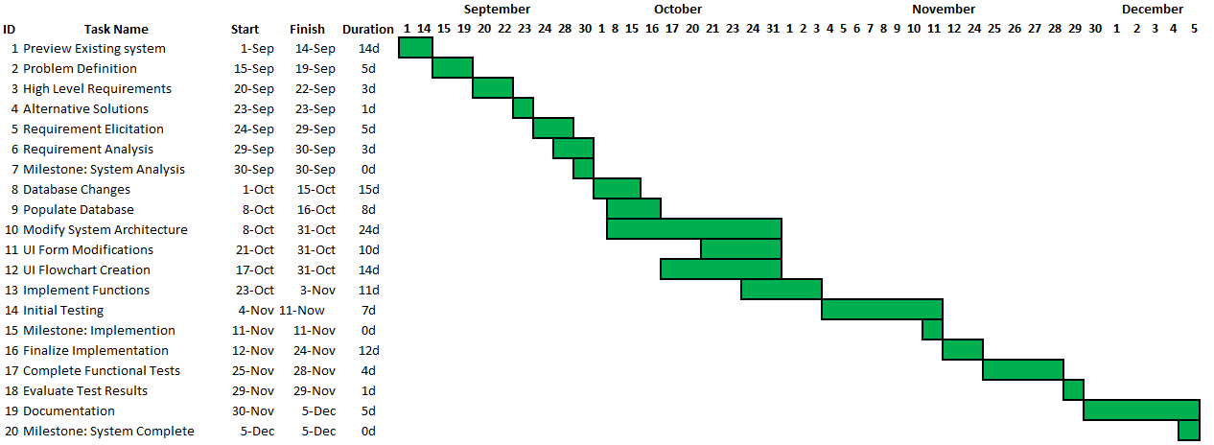

## Appendix B – All use cases with nonfunctional requirements.

**Use Case ID :** UCMSv2 – 0001

**Name :** Create DGU Proposed Catalog

**Details :** This use case allows Admin and advisor to create prospective new catalogs for their corresponding DGU. This includes prospective courses, major, minor, certificates, tracks, groups and set.

**Actors :** Admin, and advisor.

**Pre-condition(s):**

1. Advisor must be logged in into the system

**Description :**

1. Use case begins when Advisor clicks on the “Prospective Catalog” button.
2. Use select option “Create Prospective Catalog” from the prospective catalog page.
3. User must select his/her DGU.
4. User must enter catalog name.
5. User must enter description for the catalog.
6. User must enter term in which catalog will be activated.
7. User must enter the year catalog will be activated.
8. Use Case ends when user clicks in “Create New Catalog” button.

**Post condition(s):**

1. Prospective catalog must be saved in the database.

=====================================================================

**Use Case ID :** UCMSv2 – 0002

**Name :** Propose DGU Catalog.

**Details :** This use case allows Advisors to post a prospective catalog for their corresponding DGU.

**Actors :** Advisor

**Pre-condition(s):**

1. Advisor must be logged in into the system.
2. A DGU Prospective Catalog must have been already created.

**Description :**

1. Use case begins when Admin or Advisor clicks on the “Prospective Catalog” button.
2. Use select option “View Prospective Catalog” from the prospective catalog page.
3. System must display the prospective catalog.
4. Use case ends when user clicks on “Propose” button.

**Post condition(s):**

1. DGU Admin must be able to see the proposed prospective catalog.

=====================================================================

**Use Case ID :** UCMSv2 – 0003

**Name :** Accept Prospective Catalog.

**Details :** This use case allows Admin to accept prospective catalogs that have been proposed.

**Actors :** Admin

**Pre-condition(s):**

1. Advisor must be logged in into the system.
2. A DGU Prospective Catalog must have been proposed already.

**Description :**

1. Use case begins when Admin clicks on the “Prospective Catalog” button.
2. User select option “Accept / Reject Prospective Catalog” from the prospective catalog page.
3. System must display the list of proposed prospective catalogs.
4. Admin must select the prospective catalog that he/she wants to review.
5. System must display the prospective catalog
6. Admin must click the button “Accept.”

**Post condition(s):**

1. Status of the prospective catalog must change in the database.
2. The prospective catalog that was accepted must appear in the list of catalogs as accepted.

=====================================================================

**Use Case ID :** UCMSv2 – 0004

**Name :** Reject Prospective Catalog

**Details :** This use case allows Admin to reject prospective catalogs that have been proposed.

**Actors :** Admin

**Pre-condition(s):**

1. Advisor must be logged in into the system.
2. A DGU Prospective Catalog must have been proposed already.

**Description :**

1. Use case begins when Admin or Advisor clicks on the “Prospective Catalog” button.
2. Use select option “Accept / Reject Prospective Catalog” from the prospective catalog page.
3. System must display the list of proposed prospective catalogs.
4. Admin must select the prospective catalog that he/she wants to review.
5. System must display the prospective catalog
6. Admin must click the button “Reject.”

**Post condition(s):**

1. Status of the prospective catalog must change in the database.
2. The prospective catalog that was rejected must appear as a working prospective catalog for the user that created it.

=====================================================================

**Use Case ID :** UCMSv2 – 0005

**Name :** View Prospective Catalog.

**Details :** This use case allows Admin to see the prospective catalogs that have been proposed by either advisors or admin itself

**Actors :** Advisor

**Pre-condition(s):**

1. Admin must be logged in into the system.

**Description :**

1. Use case begins when Advisor clicks on the “Prospective Catalog” button.
2. Advisor selects option “View Prospective Catalogs” from the prospective catalog page.
3. Use case end when system displays the prospective catalog that advisor is working on.

**Post condition(s):** None

=====================================================================

**Use Case ID :** UCMSv2 – 0006

**Name :** View Track Flowchart.

**Details :** This use case allows users to view the track flowchart for a particular degree.

**Actors :** Users, Admins, Super Admins

**Pre-condition(s):**

1. User must select some degree.

**Description :**

1. Once the users have selected a degree track they will then be able to see the courses associated with that major.
2. In order to view the flow chart a user would have to click the “View Flowchart” button.
3. The flowchart would then be loaded divided by:
   1. Major track
      1. Groups
      2. Sets
      3. Courses
4. The flowchart components will be positioned in the same view that it was last saved in.
5. Clicking on the group will display the flowchart for that particular group. See UCMSv2- 0007.

**Post condition(s):** None

=====================================================================

**Use Case ID :** UCMSv2 – 0007

**Name :** View Group Flowchart.

**Details :** This use case allows users to view the group flowchart for a particular degree.

**Actors :** Users, Admins, Super Admins

**Pre-condition(s):**

1. User must select some degree.

**Description :**

1. Once the users have selected a degree track they will then be able to see the courses associated with that major.
2. In order to view the flow chart a user would have to click the “View Flowchart” button.
3. In order to navigate to the group level click on any group inside the track flowchart.
4. The flowchart would then be loaded divided by:
   1. Major group:
      1. Sets
      2. Courses
5. The flowchart components will be positioned in the same view that it was last saved in.
6. Clicking on the set will display the flowchart for that particular set. See UCMSv2- 0008.

**Post condition(s):** None

=====================================================================

**Use Case ID :** UCMSv2 – 0008

**Name :** View Set Flowchart.

**Details :** This use case allows users to view the set flowchart for a particular degree.

**Actors :** Users, Admins, Super Admins

**Pre-condition(s):**

1. User must select some degree.

**Description :**

1. Once the users have selected a degree track they will then be able to see the courses associated with that major.
2. In order to view the flow chart a user would have to click the “View Flowchart” button.
3. In order to navigate to the group level click on any group inside the track flowchart, and then click on any set.
4. The flowchart would then be loaded divided by:
   1. Major set:
      1. Courses
5. The flowchart components will be positioned in the same view that it was last saved in.
6. Clicking on the course will display detailed course information for that particular course.

**Post condition(s):** None

=====================================================================

**Use Case ID :** UCMSv2 – 0009

**Name :** Alter Flowchart Track Layout.

**Details :** This use case allows users to alter layout of the flowchart for a particular track.

**Actors :** Admins, Super Admins

**Pre-condition(s):**

1. User must select some degree.

**Description :**

1. Once the users have selected a degree track they will then be able to see the courses associated with that major.
2. By navigating to the track layout for the flowchart a user will see a visualization organized by groups.
3. Users can move these groups to different positions if they wish to alter their order.
4. Once the user has finished making the position changes, clicking submit will write these changes to the database.

**Post condition(s):** None

=====================================================================

**Use Case ID :** UCMSv2 – 0010

**Name :** Alter Flowchart Group Layout.

**Details :** This use case allows users to alter layout of the flowchart for a particular group.

**Actors :** Admins, Super Admins

**Pre-condition(s):**

1. User must select some degree.

**Description :**

1. Once the users have selected a degree track they will then be able to see the courses associated with that major.
2. By navigating to the group layout for the flowchart a user will see a visualization organized by sets.
3. Users can move these sets to different positions if they wish to alter their order.
4. Once the user has finished making the position changes, clicking submit will write these changes to the database.

**Post condition(s):** None

=====================================================================

**Use Case ID :** UCMSv2 – 0011

**Name :** Alter Flowchart Set Layout.

**Details :** This use case allows users to alter layout of the flowchart for a particular set.

**Actors :** Admins, Super Admins

**Pre-condition(s):**

1. User must select some degree.

**Description :**

1. Once the users have selected a degree track they will then be able to see the courses associated with that major.
2. By navigating to the set layout for the flowchart a user will see a visualization organized by courses.
3. Users can move these courses to different positions if they wish to alter their order.
4. Once the user has finished making the position changes, clicking submit will write these changes to the database.

**Post condition(s):** None

=====================================================================

**Use Case ID :** UCMSv2 – 0012

**Name :** Create Prospective Course

**Details :** This use case allows Advisor to create prospective course for the prospective catalog he/she is working on.

**Actors :** Advisor

**Pre-condition(s):**

1. Advisor must be logged in into the system.
2. A DGU Prospective Catalog must have been created already.

**Description :**

1. Use case begins when Advisor click on “Create Prospective Catalog.”
2. User clicks the “+” button in the Add courses section.
3. User must enter name for the new course.
4. User must click in the “Add” button.
5. System must display the “create prospective course” form.
6. User must enter the prefix, code, number of credits, description, and notes for the course being added.
7. Use case ends when user click on “Save” button.

**Post condition(s):**

1. A new prospective course must have been created.

=====================================================================

**Use Case ID :** UCMSv2 – 0013

**Name :** Create Prospective Set

**Details :** This use case allows Advisor to create prospective set for the prospective catalog he/she is working on.

**Actors :** Advisor

**Pre-condition(s):**

1. Advisor must be logged in into the system.
2. A DGU Prospective Catalog must have been created already.

**Description :**

1. Use case begins when Advisor click on “Create Prospective Catalog.”
2. User clicks the “+” button in the Add set section.
3. User must enter name for the new set.
4. User must click in the “Add” button.
5. System must display the “create prospective set” form.
6. User must enter the description, minimum number of credits, and the maximum number of credits for the set being added.
7. User must select the course to be added in the new set.
8. Use case ends when user click on “Save” button.

**Post condition(s):**

1. A new prospective set must have been created.

=====================================================================

**Use Case ID :** UCMSv2 – 0014

**Name :** Create Prospective Group

**Details :** This use case allows Advisor to create prospective group for the prospective catalog he/she is working on.

**Actors :** Advisor

**Pre-condition(s):**

1. Advisor must be logged in into the system.
2. A DGU Prospective Catalog must have been created already.

**Description :**

1. Use case begins when Advisor click on “Create Prospective Catalog.”
2. User clicks the “+” button in the Add group section.
3. User must enter name for the new group.
4. User must click in the “Add” button.
5. System must display the “create prospective group” form.
6. User must enter the description, minimum number of credits, and the maximum number of credits for the group being added.
7. User must select the sets to be added in the new group.
8. Use case ends when user click on “Save” button.

**Post condition(s):**

1. A new prospective group must have been created.

=====================================================================

**Use Case ID :** UCMSv2 – 0015

**Name :** Create Prospective Minor

**Details :** This use case allows Advisor to create prospective minor for the prospective catalog he/she is working on.

**Actors :** Advisor

**Pre-condition(s):**

1. Advisor must be logged in into the system.
2. A DGU Prospective Catalog must have been created already.

**Description :**

1. Use case begins when Advisor click on “Create Prospective Catalog.”
2. User clicks the “+” button in the Add minor section.
3. User must enter name for the new minor.
4. User must click in the “Add” button.
5. System must display the “create prospective minor” form.
6. User must enter the description, and the minimum number of credits for the minor being added.
7. User must select the groups to be added in the new minor.
8. Use case ends when user click on “Save” button.

**Post condition(s):**

1. A new prospective minor must have been created.

=====================================================================

**Use Case ID :** UCMSv2 – 0016

**Name :** Create Prospective Track

**Details :** This use case allows Advisor to create prospective track for the prospective catalog he/she is working on.

**Actors :** Advisor

**Pre-condition(s):**

1. Advisor must be logged in into the system.
2. A DGU Prospective Catalog must have been created already.

**Description :**

1. Use case begins when Advisor click on “Create Prospective Catalog.”
2. User clicks the “+” button in the Add track section.
3. User must enter name for the new track.
4. User must click in the “Add” button.
5. System must display the “create prospective track” form.
6. User must enter the description, and the minimum number of credits for the track being added.
7. User must select the groups to be added in the new track.
8. Use case ends when user click on “Save” button.

**Post condition(s):**

1. A new prospective track must have been created.

=====================================================================

**Use Case ID :** UCMSv2 – 0017

**Name :** Create Prospective Certificate

**Details :** This use case allows Advisor to create prospective certificate for the prospective catalog he/she is working on.

**Actors :** Advisor

**Pre-condition(s):**

1. Advisor must be logged in into the system.
2. A DGU Prospective Catalog must have been created already.

**Description :**

1. Use case begins when Advisor click on “Create Prospective Catalog.”
2. User clicks the “+” button in the Add certificate section.
3. User must enter name for the new certificate.
4. User must click in the “Add” button.
5. System must display the “create prospective certificate” form.
6. User must enter the description, and the minimum number of credits for the certificate being added.
7. User must select the groups to be added in the new certificate.
8. Use case ends when user click on “Save” button.

**Post condition(s):**

1. A new prospective certificate must have been created.

=====================================================================

**Use Case ID :** UCMSv2 – 0018

**Name :** Create Prospective Major

**Details :** This use case allows Advisor to create prospective major for the prospective catalog he/she is working on.

**Actors :** Advisor

**Pre-condition(s):**

1. Advisor must be logged in into the system.
2. A DGU Prospective Catalog must have been created already.

**Description :**

1. Use case begins when Advisor click on “Create Prospective Catalog.”
2. User clicks the “+” button in the Add major section.
3. User must enter name for the new major.
4. User must click in the “Add” button.
5. System must display the “create prospective major” form.
6. User must enter the description for the major set being added.
7. User must select the tracks to be added in the new major.
8. Use case ends when user click on “Save” button.

**Post condition(s):**

1. A new prospective major must have been created.

=====================================================================

**Use Case ID :** UCMSv2 – 0019

**Name :** Edit Prospective Course

**Details :** This use case allows Advisor to make prospective change to a course for the prospective catalog he/she is working on.

**Actors :** Advisor

**Pre-condition(s):**

1. Advisor must be logged in into the system.
2. A DGU Prospective Catalog must have been created already.
3. A course must exist.

**Description :**

1. Use case begins when Advisor click on “Create Prospective Catalog.”
2. User clicks the “+edit” button in the Add courses section.
3. User must select course to be edited.
4. System must display the “prospective course” form with all field filled out with the current information.
5. User must enter changes to the prefix, code, number of credits, description, and notes for the course being edited.
6. Use case ends when user click on “Save” button.

**Post condition(s):**

1. Changes to the course must been saved in the database.

=====================================================================

**Use Case ID :** UCMSv2 – 0020

**Name :** Edit Prospective Set

**Details :** This use case allows Advisor to make prospective change to a set for the prospective catalog he/she is working on.

**Actors :** Advisor

**Pre-condition(s):**

1. Advisor must be logged in into the system.
2. A DGU Prospective Catalog must have been created already.
3. A set must exist.

**Description :**

1. Use case begins when Advisor click on “Create Prospective Catalog.”
2. User clicks the “+edit” button in the Add set section.
3. User must select set to be edited.
4. System must display the “prospective set” form with all field filled out with the current information.
5. User must enter changes to the minimum number of credits, description, and the maximum number of credits for the set being edited.
6. User must click on “Save” button.
7. User has the option to either add course or remove course to the set he/she is editing by clicking either on the “Add Course” or “Remove Course” button.

**Post condition(s):**

1. Changes to the set must been saved in the database.

=====================================================================

**Use Case ID :** UCMSv2 – 0021

**Name :** Edit Prospective Group

**Details :** This use case allows Advisor to make prospective change to a group for the prospective catalog he/she is working on.

**Actors :** Advisor

**Pre-condition(s):**

1. Advisor must be logged in into the system.
2. A DGU Prospective Catalog must have been created already.
3. A group must exist.

**Description :**

1. Use case begins when Advisor click on “Create Prospective Catalog.”
2. User clicks the “+edit” button in the Add group section.
3. User must select group to be edited.
4. System must display the “prospective group” form with all field filled out with the current information.
5. User must enter changes to the minimum number of credits, description, and the maximum number of credits for the group being edited.
6. User must click on “Save” button.
7. User has the option to either add set or remove set to the group he/she is editing by clicking either on the “Add Set” or “Remove Set” button.

**Post condition(s):**

1. Changes to the group must been saved in the database.

=====================================================================

**Use Case ID :** UCMSv2 – 0022

**Name :** Edit Prospective Minor

**Details :** This use case allows Advisor to make prospective change to a minor for the prospective catalog he/she is working on.

**Actors :** Advisor

**Pre-condition(s):**

1. Advisor must be logged in into the system.
2. A DGU Prospective Catalog must have been created already.
3. A minor must exist.

**Description :**

1. Use case begins when Advisor click on “Create Prospective Catalog.”
2. User clicks the “+edit” button in the Add minor section.
3. User must select minor to be edited.
4. System must display the “prospective minor” form with all field filled out with the current information.
5. User must enter changes to the minimum number of credits, and description for the minor being edited.
6. User must click on “Save” button.
7. User has the option to either add group or remove group to the minor he/she is editing by clicking either on the “Add Group” or “Remove Group” button.

**Post condition(s):**

1. Changes to the minor must been saved in the database.

=====================================================================

**Use Case ID :** UCMSv2 – 0023

**Name :** Edit Prospective Track

**Details :** This use case allows Advisor to make prospective change to a track for the prospective catalog he/she is working on.

**Actors :** Advisor

**Pre-condition(s):**

1. Advisor must be logged in into the system.
2. A DGU Prospective Catalog must have been created already.
3. A track must exist.

**Description :**

1. Use case begins when Advisor click on “Create Prospective Catalog.”
2. User clicks the “+edit” button in the Add track section.
3. User must select track to be edited.
4. System must display the “prospective track” form with all field filled out with the current information.
5. User must enter changes to the minimum number of credits, and description for the track being edited.
6. User must click on “Save” button.
7. User has the option to either add group or remove group to the track he/she is editing by clicking either on the “Add Group” or “Remove Group” button.

**Post condition(s):**

1. Changes to the track must been saved in the database.

=====================================================================

**Use Case ID :** UCMSv2 – 0024

**Name :** Edit Prospective Certificate

**Details :** This use case allows Advisor to make prospective change to a certificate for the prospective catalog he/she is working on.

**Actors :** Advisor

**Pre-condition(s):**

1. Advisor must be logged in into the system.
2. A DGU Prospective Catalog must have been created already.
3. A certificate must exist.

**Description :**

1. Use case begins when Advisor click on “Create Prospective Catalog.”
2. User clicks the “+edit” button in the Add certificate section.
3. User must select certificate to be edited.
4. System must display the “prospective certificate” form with all field filled out with the current information.
5. User must enter changes to the minimum number of credits, and description for the certificate being edited.
6. User must click on “Save” button.
7. User has the option to either add group or remove group to the certificate he/she is editing by clicking either on the “Add Group” or “Remove Group” button.

**Post condition(s):**

1. Changes to the certificate must been saved in the database.

=====================================================================

**Use Case ID :** UCMSv2 – 0025

**Name :** Edit Prospective Major

**Details :** This use case allows Advisor to make prospective change to a major for the prospective catalog he/she is working on.

**Actors :** Advisor

**Pre-condition(s):**

1. Advisor must be logged in into the system.
2. A DGU Prospective Catalog must have been created already.
3. A major must exist.

**Description :**

1. Use case begins when Advisor click on “Create Prospective Catalog.”
2. User clicks the “+edit” button in the Add major section.
3. User must select major to be edited.
4. System must display the “prospective major” form with all field filled out with the current information.
5. User must enter changes to the description for the certificate being edited.
6. User must click on “Save” button.
7. User has the option to either add track or remove track to the major he/she is editing by clicking either on the “Add Track” or “Remove Track” button.

**Post condition(s):**

1. Changes to the major must been saved in the database.

## Appendix C – User Interface designs.

Set Flow:

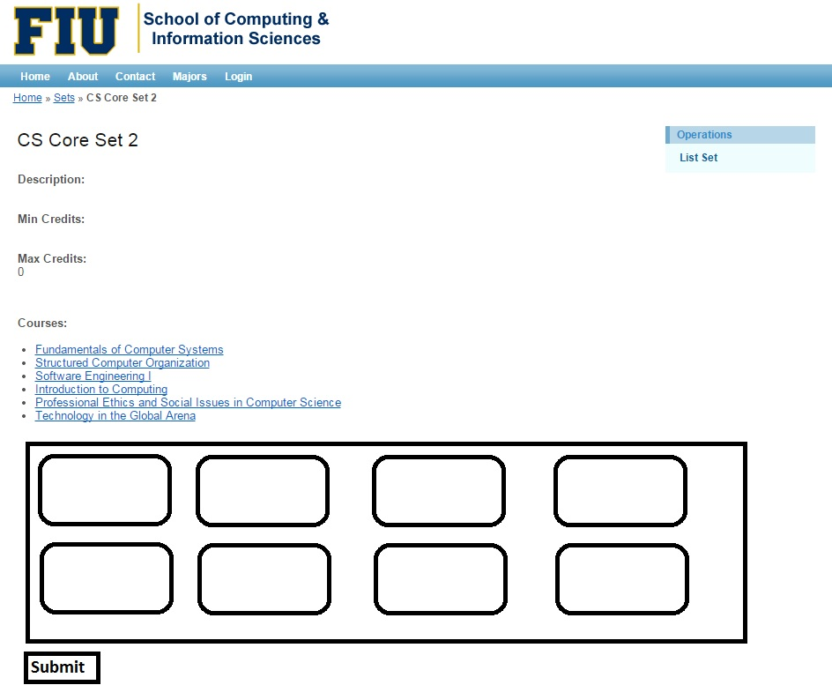

Group Flow:

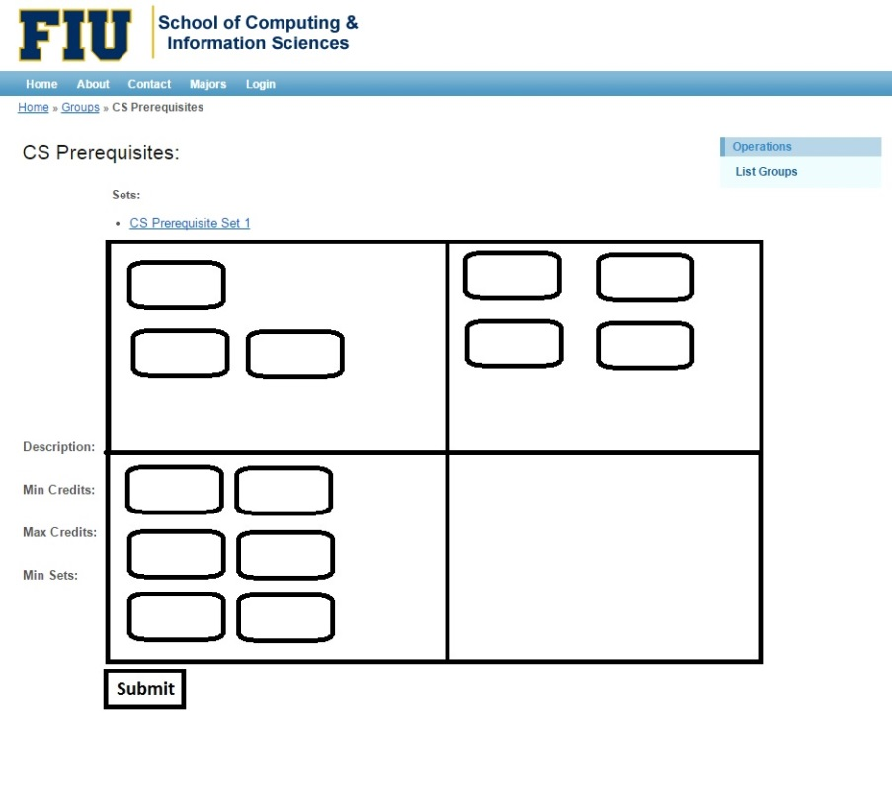

Track Flow:

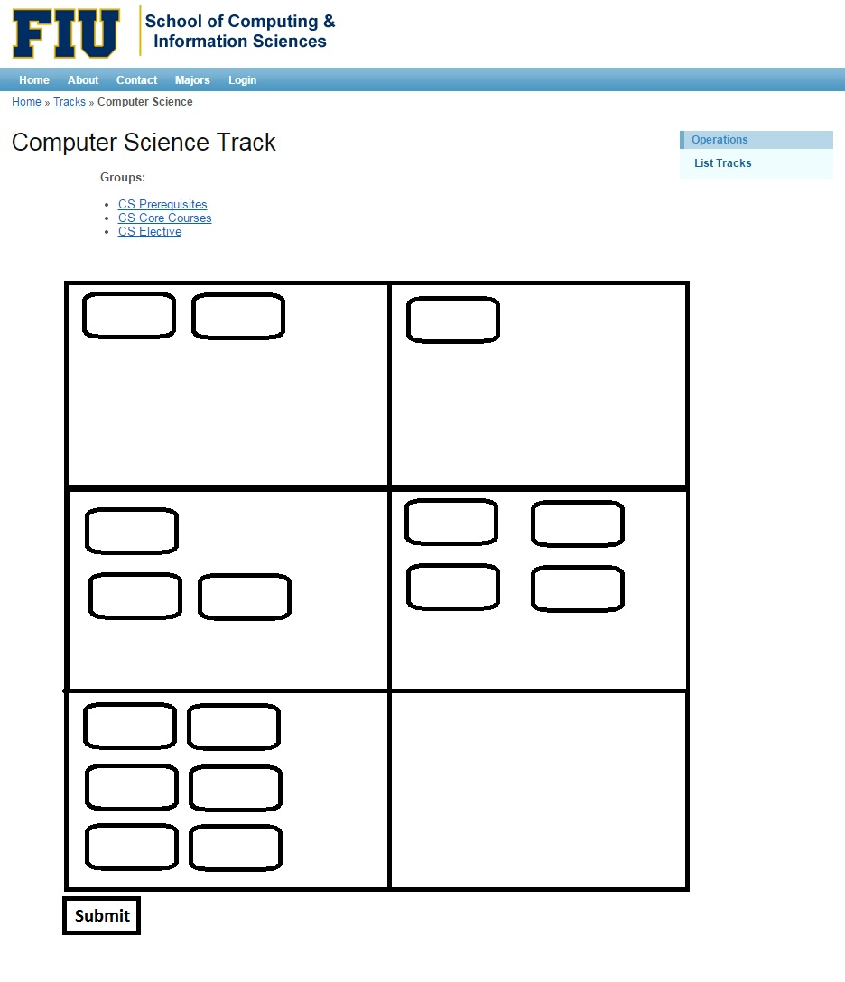

Prospective Catalog Menu:

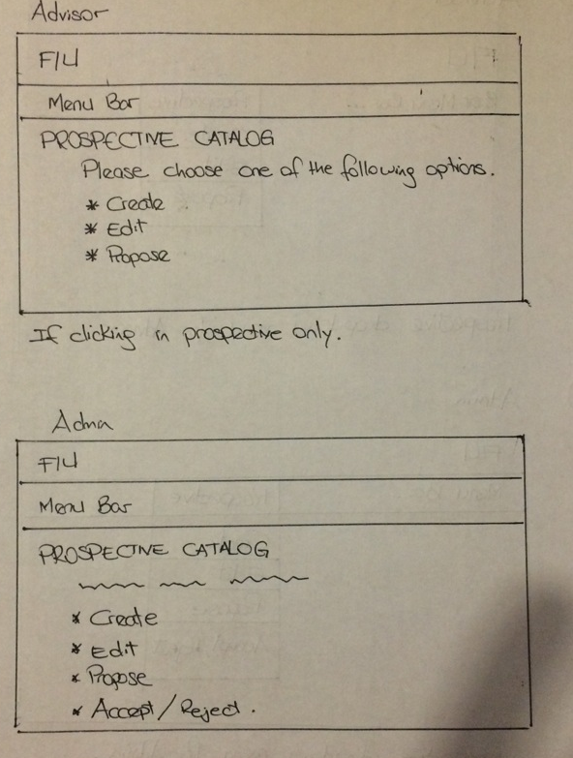

View Prospective Catalog:

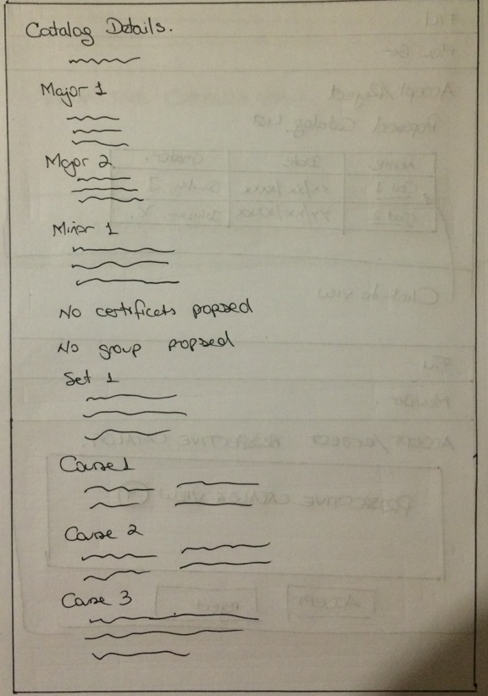

Propose Prospective Catalog:

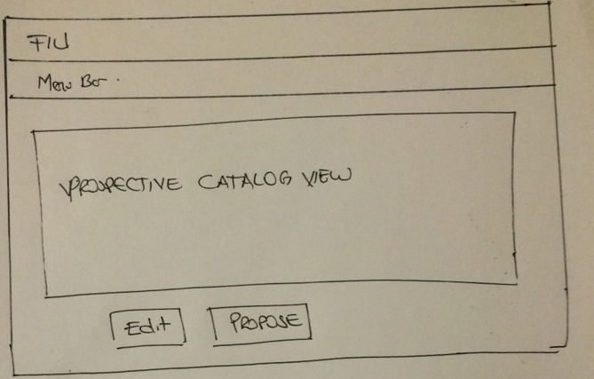

Accept and Reject Prospective Catalog Selection:

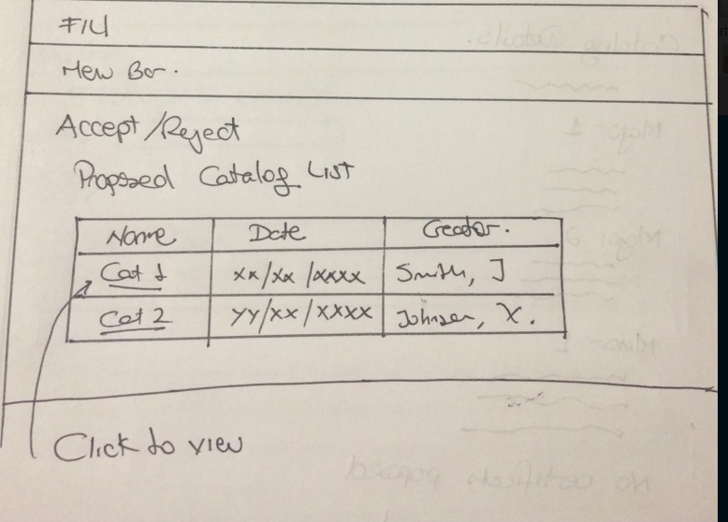

Accept and Reject Prospective Catalog:

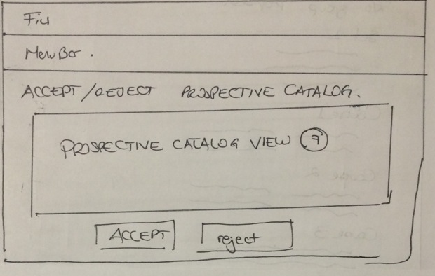

## Appendix D – Analysis models

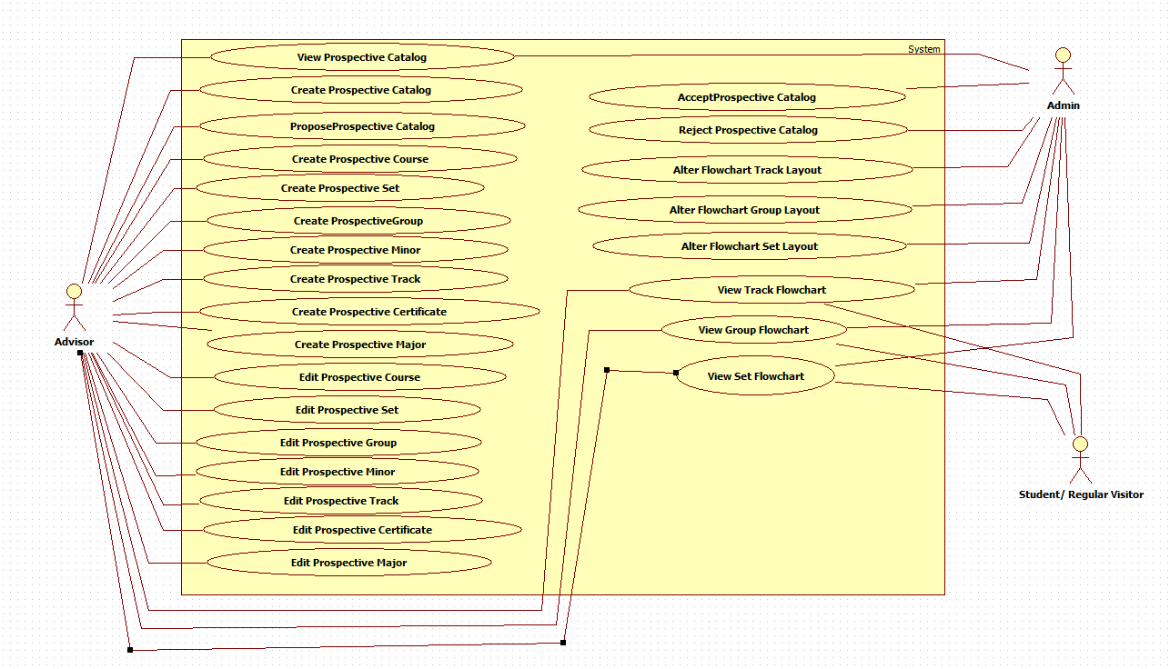

## Appendix E – Design models (static and dynamic)

CMS_Controller Subsystem:



CMS_Model Subsystem:



Prospective Catalog Subsystem:



Flowchart Subsystem:



## Dynamic Model

Below are the sequence diagrams refined:

UCMSv2-0001: Create Prospective DGU Catalog:



UCMSv2-0002: Propose Prospective DGU Catalog:



UCMSv2-0003 : Accept Prospective Catalog:



UCMSv2-0004 : Reject Prospective Catalog:



UCMSv2-0005 : View Prospective Catalog:



UCMSv2-0006 : View Track Flowchart (a):



UCMSv2-0006 : View Track Flowchart (b):



UCMSv2-0007 : View Group Flowchart (a):



UCMSv2-0007 : View Group Flowchart (b):



UCMSv2-0008 : View Set Flowchart (a):



UCMSv2-0008 : View Set Flowchart (b):



UCMSv2-0009 : Change Track Flowchart:



UCMSv2-0010 : Change Group Flowchart:



UCMSv2-0011 : Change Set Flowchart:



UCMSv2-0012 : Create Prospective Course:



UCMSv2-0013 : Create Prospective Set:



UCMSv2-0014 : Create Prospective Group:



UCMSv2-0015 : Create Prospective Minor:



UCMSv2-0016 : Create Prospective Track:



UCMSv2-0017: Create Prospective Certificate:



UCMSv2-0018 : Create Prospective Major:



UCMSv2-0019 : Edit Prospective Course:



UCMSv2-0020 : Edit Prospective Set:



UCMSv2-0021 : Edit Prospective Group:



UCMSv2-0022 : Edit Prospective Minor:



UCMSv2-0023 : Edit Prospective Track:



UCMSv2-0024 : Edit Prospective Certificate:



UCMSv2-0025 : Edit Prospective Major:



## Appendix F – Documented Class interfaces (code) and constraints.

**Prospective Catalog Subsystem**

The following are the classes that are needed for the prospective catalog subsystem.

These are the prospectiveCatalogController.php and the createProspective.js which can be found under prospective catalog forms.

Function on prospectiveCatalogController.php

* GetLastCatalogID()
* InsertNewCatalog()
* ProposeProspectiveCatalog()
* LoadProspectiveCatalog()
* ProposeCatalogFromView()
* AcceptCatalog()
* RejectCatalog()
* AddTrackMajor()
* RemoveTrackMajor()
* RetrieveMajorFields()
* SaveNewMajor()
* UpdateMajor()
* AddGroupMinor()
* RemoveGroupMinor()
* SaveNewMinor()
* RetrieveMinorFields()
* UpdateMinor()
* AddGroupCertificate()
* RemoveGroupCertificate()
* SaveNewCertificate()
* RetrieveCertificateFields()
* UpdateCertificate()
* AddGroupTrack ()
* RemoveGroupTrack ()
* SaveNewTrack ()
* RetrieveTrackFields()
* UpdateTrack()
* AddSetGroup()
* RemoveSetGroup()
* SaveNewGroup()
* UpdateGroup()
* RetriveGroupFields()
* AddCourseSet()
* RemoveCourseSet()
* SaveNewSet()
* UpdateSet()
* RetrieveSetFields()
* SaveNewCourse()
* RetrieveCourseFields()
* UpdateCourse()

Functions on createProspectiveJS.php ( this contains only JS functions )

* onNewCatalogClick()
* onNewProspectiveCatalogClick()
* close_major_form()
* close_emajor_form()
* saveNewMajor()
* updateMajor()
* addeMajor()
* addMajor()
* addTrackRowInMajor()
* addTrackToMajor()
* removeTrackFromMajor()
* onMajorInputsClick()
* oneMajorInputsClick()
* close_minor_form()
* close_eminor_form()
* saveNewMinor()
* updateMinor()
* addeMinor()
* addMinor()
* addGroupRowInMinor()
* addGroupToMinor()
* removeGroupFromMinor()
* onaddminorfieldrowsClick()
* oneditminorfieldrowsClick()
* removeRwoGroupInMinor()
* onMinorInputsClick()
* oneMinorInputsClick()
* close_certificate_form()
* close_ecertificate_form()
* saveNewCertificate()
* updateCertificate()
* addeCertificate()
* addCertificate()
* addGroupRowInCertificate()
* addGroupToCertificate(0
* removeGroupFromCertificate()
* onAddCertificateFieldRowsClick()
* removeRowGroupInCertificate()
* onCertificateInputsClick()
* oneCertificaeInputsClick()
* close_etrack_form()
* close_track_form()
* addTrack()
* saveNewTrack()
* updateTrack()
* addeTrack()
* addGroupRowInTrack()
* addGroupToTrack()
* removeGroupFromTrack()
* onAddTrackFieldRowsClick()
* onEditTrackFieldRowsClick()
* removeRowGroupInTrack()
* onTrackInputsClick()
* oneTrackInputsClick()
* close_group_form()
* close_egroup_form()
* saveNewGroup()
* updateGroup()
* addGroup()
* addSetToGroup()
* removeSetFromGroup()
* addSetRowInGroup()
* removeSetRowInGroup()
* addeGroup()
* onAddGroupFieldRowsClick()
* onEditGroupFieldRowsClick()
* onGroupInputsClick()
* oneGroupInputsClick()
* close_eset_form()
* close_set_form()
* addCourseToSet()
* removeCourseFromSet()
* addCourseRowInSet()
* removeCourseRowInSet()
* addeSet()
* addSet()
* saveNewSet()
* onAddSetFieldRowsClick()
* updateSet()
* onEditSetFieldRowsClick()
* onSetInputsClick()
* oneSetInputsClick()
* close_course_form()
* close_ecourse_form()
* addeCourse()
* updateCourse()
* saveNewCourse()
* addCourse()
* onEditCourseFieldRowsClick()
* onAddCourseFieldRowsClick()
* onCourseInputsClick()
* oneCourseInputsClick()

Function on viewProspective.js

* goToCreate()
* propose()
* acceptCatalog()
* rejectCatalog()

**Flowchart generation Subsystem**

The following are the classes that are needed for the generation of flowchart subsystem.

Functions on Flowchartdrag.js

* Box()
* allowDrop()
* drag()
* drop()
* dragStart()
* dragEnd()

Function on SetController.php

* actionFlowSet()

Function on GroupController.php

* actionFlowGroup()

Function on TrackController.php

* actionFlowTrack()

Function on CourseFlowInfo.php

* getCourseInfo()
* getSetInfo()
* getGroupInfo()
* getDefaultSet()
* getDefaultGroup()
* getDefaultTrack()

## Appendix G – Documented code for test drivers and stubs.

## Appendix H – Diary of meetings

|  |  |
| --- | --- |
| Diary Entry 1 | |
| Date | Wednesday, September 3rd, 2014 |
| Location | ECS 341 |
| Start | 7:00 PM |
| End | 8:00 PM |
| Attendees | * Jose Astudillo * Christopher Sutton * Tim Downey |
| Agenda | * Review the existing system. * Get requirements for the project. |
| Summary | * Defined tools to be used for the development. * Explanation of the current system. * Brief definition of the functionalities to be implement for this version of the system. |
| Assigned Tasks | For both team members:   * Explore current system. * Get familiar with the tools to be used. |

|  |  |  |
| --- | --- | --- |
| Diary Entry 2 | | |
| Date | Sunday, September 7th, 2014 | |
| Location | JCCL Lab | |
| Start | 4:00 PM | |
| End | 7:00 PM | |
| Attendees | * Jose Astudillo * Christopher Sutton | |
| Agenda | * Start working on project plan. * Revise Feasibility Analysis document. * Revise SRD. * Work on Trello. | |
| Summary | * Trello was set up. * Worked on Feasibility document. * Worked on SRD. * Brief work on project plan. | |
| Assigned Tasks | Jose: work on SRD.  Christopher: work on feasibility document. | |
| Diary Entry 3 | |
| Date | Monday, September 8th, 2014 |
| Location | ECS 341 |
| Start | 7:00 PM |
| End | 8:00 PM |
| Attendees | * Jose Astudillo * Christopher Sutton * Tim Downey |
| Agenda | * Run v1.0 locally * Discuss functionalities to be implemented. |
| Summary | * Tried to run v1.0 locally. * Discussed about adding new user. Now, there will be 4 types of users: admin, student, advisors, and the regular visitor. * Christopher was assigned to work on administrator modules; additionally, he might complete some work on regular user. * Jose was assigned to work on advisor module mainly; however, he might work also in the student module. |
| Assigned Tasks | * Keep trying to get v1.0 to run locally. * Start writing use cases, and create sequence diagrams. |

|  |  |
| --- | --- |
| Diary Entry 4 | |
| Date | Wednesday, September 10th, 2014 |
| Location | ECS 341 |
| Start | 7:00 PM |
| End | 8:00 PM |
| Attendees | * Jose Astudillo * Christopher Sutton * Tim Downey |
| Agenda | * Run v1.0 of CMS locally. |
| Summary | * v1.0 running successfully. |
| Assigned Tasks | * Keep trying to get v1.0 to run locally. * Start writing use cases, and create sequence diagrams. * Familiarize ourselves with Yii framework. * Get familiar with the database. |

|  |  |
| --- | --- |
| Diary Entry 5 | |
| Date | Monday, September 15th, 2014 |
| Location | ECS 341 |
| Start | 6:30 PM |
| End | 7:30 PM |
| Attendees | * Jose Astudillo * Christopher Sutton * Tim Downey |
| Agenda | * Discuss system needs. |
| Summary | * Discussed what needs to be completed next. |
| Assigned Tasks | * Complete documents for use cases. * Make sequence diagrams from the use cases. * Create UI for the use cases to be implemented. |

|  |  |
| --- | --- |
| Diary Entry 6 | |
| Date | Monday, September 29th, 2014 |
| Location | ECS 341 |
| Start | 6:30 PM |
| End | 7:30 PM |
| Attendees | * Jose Astudillo * Tim Downey |
| Agenda | * Talked about create, edit, and propose prospective catalogs. |
| Summary | * Discussed about the flow for creating, editing, and proposing prospective catalogs. |
| Assigned Tasks | * Keep writing use cases, and creating diagrams. |

|  |  |
| --- | --- |
| Diary Entry 7 | |
| Date | Wednesday, October 1st, 2014 |
| Location | ECS 341 |
| Start | 6:30 PM |
| End | 8:00 PM |
| Attendees | * Tim Downey * Christopher Sutton |
| Agenda | * Discussion about Yii framework in detail. |
| Summary | * Talked about the controller and view set ups for degree unit, |
| Assigned Tasks | * Continue exploration of Yii framework and work on documentation. |
| Diary Entry 8 | |
| Date | Monday, October 6th, 2014 |
| Location | ECS 341 |
| Start | 6:30 PM |
| End | 7:30 PM |
| Attendees | * Jose Astudillo * Christopher Sutton * Tim Downey |
| Agenda | * Discuss changes to the database for implementing prospective catalogs. * Discuss changes for implementing new type of users. * Discuss algorithm for flow chart implementation. |
| Summary | * Discussed changes to the database for implementing prospective catalogs. * Discussed changes for implementing new types of users. * Permission granted by Tim Downey to work on the flowchart. |
| Assigned Tasks | Jose:   * Start creating views for the system. * Make changes to the database so that it can accept new users. * Make changes to the catalog table so that it can work with prospective catalogs.   Chris:   * Work on the flowchart algorithm. |

|  |  |
| --- | --- |
| Diary Entry 9 | |
| Date | Wednesday, October 8th, 2014 |
| Location | ECS 341 |
| Start | 6:30 PM |
| End | 8:00 PM |
| Attendees | * Tim Downey * Christopher Sutton |
| Agenda | * Show graphical API to use for the flow chart implementation |
| Summary | * Two API were show: Tree Map, and Org Chart. |
| Assigned Tasks | * Put required information into charts which can then be linked at a later date. |

|  |  |
| --- | --- |
| Diary Entry 10 | |
| Date | Friday, October 10th, 2014 |
| Location | ECS 341 |
| Start | 2:00 PM |
| End | 3:00 PM |
| Attendees | * Tim Downey * Christopher Sutton |
| Agenda | * Discussed table structure for flowchart visualization. |
| Summary | * Learned how to use tables created as a base point for linking. * Explored tables currently being used by panther soft. |
| Assigned Tasks | * Implement current table structure based of panther soft model. |

|  |  |
| --- | --- |
| Diary Entry 11 | |
| Date | Monday, October 13th, 2014 |
| Location | ECS 341 |
| Start | 6:30 PM |
| End | 8:30 |
| Attendees | * Jose Astudillo * Christopher Sutton * Tim Downey |
| Agenda | * Discuss presentation concerns. * Discussed topic suggested to automate students schedule for the next semester. * Discuss pop up implementation. |
| Summary | * The automation need was outside the project according to Tim Downey. * Decided to implement the flowchart using dynamic object modelling. |
| Assigned Tasks | Jose:   * Work on pop up.   Christopher:   * Start implementing flowchart algorithm. |

|  |  |
| --- | --- |
| Diary Entry 12 | |
| Date | Wednesday, October 15th, 2014 |
| Location | ECS 341 |
| Start | 6:30 PM |
| End | 7:30 PM |
| Attendees | * Jose Astudillo * Christopher Sutton * Tim Downey |
| Agenda | * Discuss Yii framework. * Discuss process for using DOM to create flow chart. |
| Summary | * Discussed problems using Yii active forms. * Discovered a large data gap; no pre/co requisites were listed in the databases. * Chris proposed a schema to implement which was accepted by Tim Downey. |
| Assigned Tasks | Jose:   * Keep working on pop up forms.   Christopher:   * Keep working on flow chart implementation. |

|  |  |
| --- | --- |
| Diary Entry 13 | |
| Date | Friday, October 17th, 2014 |
| Location | ECS 341 |
| Start | 2:00 PM |
| End | 3:00 PM |
| Attendees | * Tim Downey. * Christopher Sutton |
| Agenda | * Showed Tim Downey new tables for the flowchart visualization. |
| Summary | * Chris was provided with an example of a program using object modelling. |
| Assigned Tasks | * Ensure courses can be moved dynamically around the page. |

|  |  |
| --- | --- |
| Diary Entry 14 | |
| Date | Monday, October 20th , 2014 |
| Location | ECS 341 |
| Start | 6:30 PM |
| End | 8:30 PM |
| Attendees | * Jose Astudillo * Christopher Sutton * Tim Downey |
| Agenda | * Discuss about implementation of pop up form using Yii active form, or using JQuery. * Show current flexibility and layout of the dynamic flow chart form. |
| Summary | * Discussed methods that would allow saving the layout and its ability to be reloaded. * Discussed using JQuery. |
| Assigned Tasks | Jose:   * Keep working on forms.   Christopher:   * Look at methods for saving layout of groups, sets, and courses. |

|  |  |
| --- | --- |
| Diary Entry 15 | |
| Date | Wednesday, October 22nd, 2014 |
| Location | ECS 341 |
| Start | 6:30 PM |
| End | 8:30 PM |
| Attendees | * Jose Astudillo * Christopher Sutton * Tim Downey |
| Agenda | * Discuss problems in flowchart. |
| Summary | * Decided to use JQuery to pop up form for the different inputs of the prospective. * Fixed minor bug issues. * Showed current dynamic functionality. |
| Assigned Tasks | Jose:   * Keep working on pop up forms.   Christopher:   * Working on saving layout and implementing tables to accommodate the ability to save a positon. |

|  |  |
| --- | --- |
| Diary Entry 16 | |
| Date | Friday, October 24th, 2014 |
| Location | ECS 341 |
| Start | 2:00 PM |
| End | 3:00 PM |
| Attendees | * Tim Downey * Christopher Sutton |
| Agenda | * Discuss current flowchart implementation. |
| Summary | * Errors fixed in JS. * Left columns fixed. * Discussed on saving object location to database. |
| Assigned Tasks | * Work on creating a table that can link a degree track to a flowchart id. |

|  |  |
| --- | --- |
| Diary Entry 17 | |
| Date | Friday, October 31st, 2014 |
| Location | ESC 341 |
| Start | 2:00 PM |
| End | 3:00 PM |
| Attendees | * Tim Downey * Christopher Sutton |
| Agenda | * Discussed current progress. * Identified a solution to placing course information inside DIV’s. * Algorithm proposed for placing each course in the correct positon. |
| Summary | * Progress with the algorithm and overall structure of the database. |
| Assigned Tasks | * Implement table changes. * Implement hidden fields to record table information. |

|  |  |
| --- | --- |
| Diary Entry 18 | |
| Date | Monday, November 3rd, 2014 |
| Location | ESC 341 |
| Start | 6:30PM |
| End | 7:30 PM |
| Attendees | * Tim Downey * Christopher Sutton |
| Agenda | * Demonstrated current progress. * Discuss documentation changes. * Elaborate on hidden field functionality. |
| Summary | * Demonstrated current functionality and discussed future changes to database and system. |
| Assigned Tasks | * Continue working on flowchart visualization. |

|  |  |
| --- | --- |
| Diary Entry 19 | |
| Date | Wednesday, November 5th, 2014 |
| Location | ECS 341 |
| Start | 6:30 PM |
| End | 8:00 PM |
| Attendees | * Christopher Sutton * Tim Downey |
| Agenda | * Discuss final layout for flowchart visualization. * Discussed database. * Hidden fields functioning. |
| Summary | * Layout of the visualization agreed upon. * Database changes need to be made. |
| Assigned Tasks | Christopher:   * Add Flow_Group and Flow_Set tables. * Create a controller for the FlowChart * Create a model for Flow_Course. |

|  |  |
| --- | --- |
| Diary Entry 20 | |
| Date | Friday, November 7th, 2014 |
| Location | ESC 341 |
| Start | 2:00 PM |
| End | 3:00 PM |
| Attendees | * Tim Downey * Christopher Sutton |
| Agenda | * Discussed models and controllers in Yii. * Determined the best was to interpret Post Data from the flowchart. * Worked on submitting values to the database. * Created views, forms, controllers, models, and links for the Flow_Course relation. * Discussed the need for data parsing when dealing with hidden values. * Overall developed a greater understanding of the Yii Framework. |
| Summary | * Significant progress made with database and flowchart visualization. * Set views completed. |
| Assigned Tasks | * Continue finishing implementation. |

|  |  |
| --- | --- |
| Diary Entry 21 | |
| Date | Monday, November 10th, 2014 |
| Location | ESC 341 |
| Start | 6:30 PM |
| End | 8:00 PM |
| Attendees | * Tim Downey * Christopher Sutton |
| Agenda | * Demonstrate current functionality with a focus on the core building block of a set that contains courses. * Dynamic modelling demonstration to allow users to interact with the model visualization. |
| Summary | * Set view working dynamically and acts as building block for the entire flowchart visualization. |
| Assigned Tasks | * In order to continue building upon the Set view the database tables will have to be modified in order to store multiple flowcharts for a signal set, group, or track. Schema proposed. |
| Diary Entry 22 | |
| Date | Wednesday, November 12th, 2014 |
| Location | ESC 341 |
| Start | 6:30 PM |
| End | 8:00 PM |
| Attendees | * Tim Downey * Christopher Sutton |
| Agenda | * Demonstrate current functionality. * Demonstrate finalized database for the flowchart. * Initiated plan for implementing Group and Track charts. * Discussed possibility for being able to tie a chart to a specific user (May be out of scope for this cycle) |
| Summary | * Database finalized. * Group and Track plans initialized. |
| Assigned Tasks | * Implement Track and Group charts. |

|  |  |
| --- | --- |
| Diary Entry 23 | |
| Date | Monday, November 24th, 2014 |
| Location | ESC 341 |
| Start | 6:30 PM |
| End | 9:00 PM |
| Attendees | * Tim Downey * Christopher Sutton |
| Agenda | * Demonstrated finished flowchart functionality. * Discussed a few changes to the design and layout which can be manipulated in CSS. * Discussed refining algorithm to take in to account the number of pre-requisites for each course for a default view chart. |
| Summary | * Flowchart visualization completed. * Design needs modification. |
| Assigned Tasks | * Work on flowchart design. * Work on documentation. |

# References